Task on VPC Transit Gateway &
VPC Endpoint

1) Create one VPC, with 1 public subnet and 1 private subnet.
2) Enable VPC peering for cross-region.
3) Enable VPC peering for cross-account (you can collaborate with your friend to do this task).
4) Set up a VPC Transit Gateway.
5) Set up a VPC Endpoint.

Prerequisites
- An active AWS account with IAM permissions for VPC, EC2, and (for Task 3) a second AWS account belonging to a friend/colleague.
- AWS Management Console access.
- Basic understanding of IP addressing / CIDR blocks.
- For Task 3, you will need your friend's AWS Account ID and their cooperation to accept a peering request in their own console.
IP plan used throughout this guide (adjust as needed, just keep the ranges non-overlapping):
Resource | Region | CIDR
VPC-A (Main lab VPC) | ap-south-1 (Mumbai) | 10.0.0.0/16
VPC-A Public Subnet | ap-south-1a | 10.0.1.0/24
VPC-A Private Subnet | ap-south-1a | 10.0.2.0/24
VPC-B (Peering target) | us-east-1 (N. Virginia) | 10.1.0.0/16
VPC-C (Friend's account) | ap-south-1 | 10.2.0.0/16
VPC-D (Transit Gateway attach) | ap-south-1 | 10.3.0.0/16

TASK 1: Create a VPC with 1 Public Subnet and 1 Private Subnet

Step 1.1 — Open the VPC Console
1. Log in to the AWS Management Console.
2. In the top search bar, type VPC and click VPC (under Services).
3. Confirm the region selector (top-right) shows your desired region, e.g., Asia Pacific (Mumbai) ap-south-1.
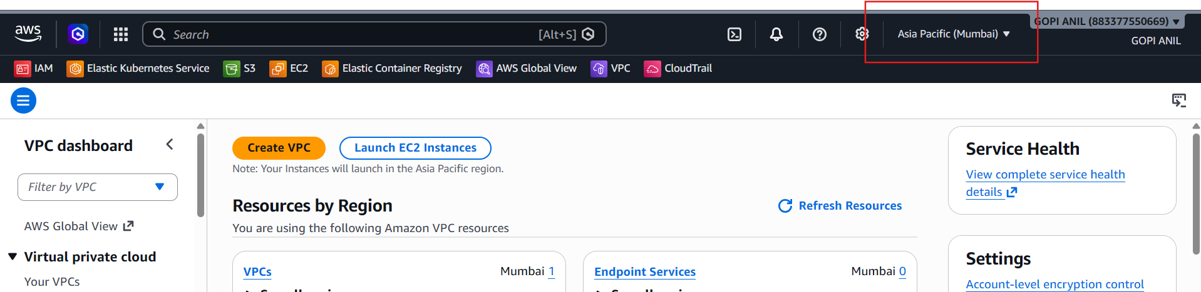

Step 1.2 — Create the VPC
1. In the left navigation pane, click Your VPCs.
2. Click Create VPC (orange button, top-right).
3. Select VPC only (we will create subnets manually to understand the process).
4. Fill in the fields: Name tag = VPC-A; IPv4 CIDR block = 10.0.0.0/16 (manual input); IPv6 CIDR block = No IPv6 CIDR block; Tenancy = Default.
5. Click Create VPC.
6. A confirmation banner appears: “Successfully created VPC vpc-xxxxxxxx.” Note the VPC ID.
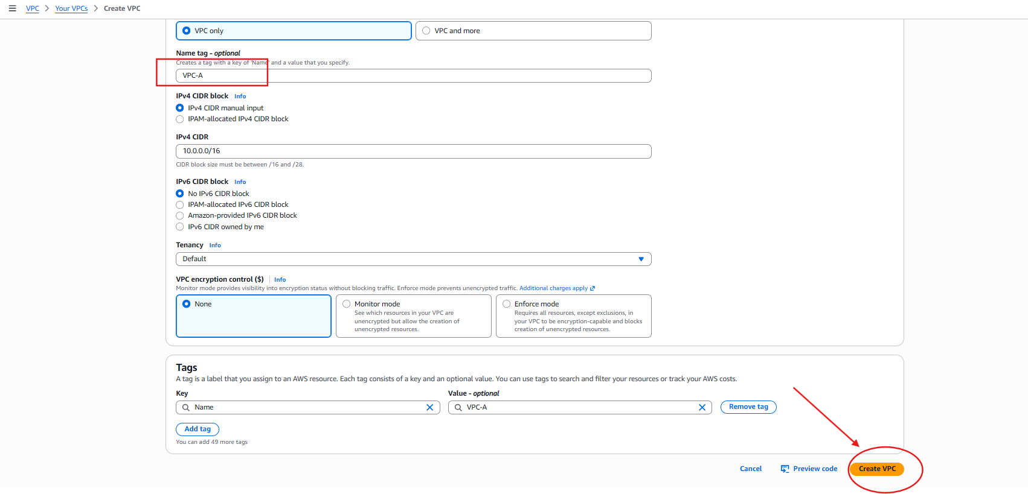
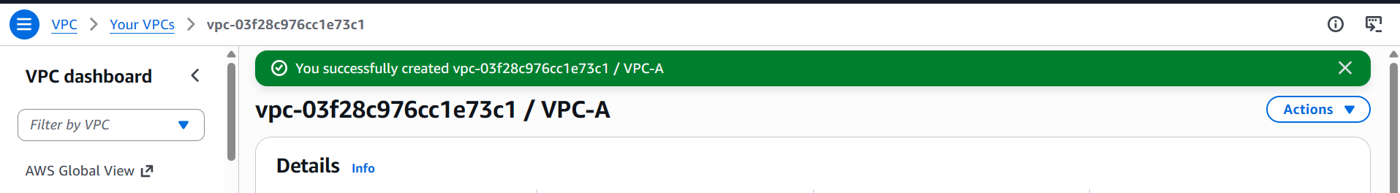

Step 1.3 — Create the Public Subnet
1. Left pane → click Subnets.
2. Click Create subnet.
3. VPC ID: select VPC-A.
4. Subnet settings: Subnet name = Public-Subnet; Availability Zone = ap-south-1a; IPv4 CIDR = 10.0.1.0/24.
5. Click Create subnet.
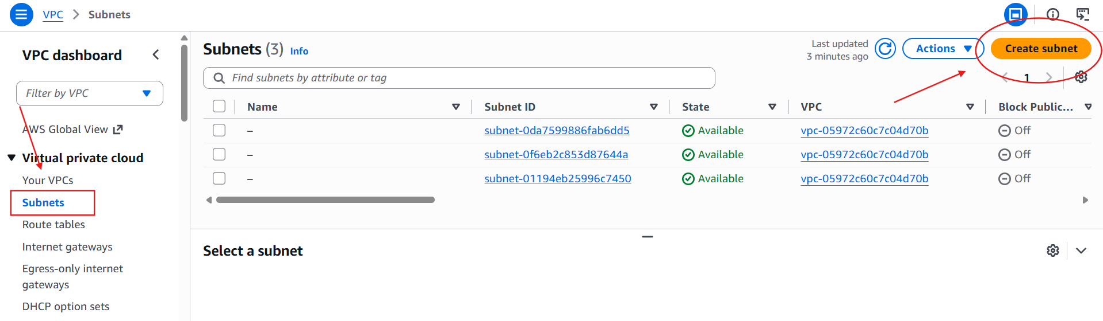
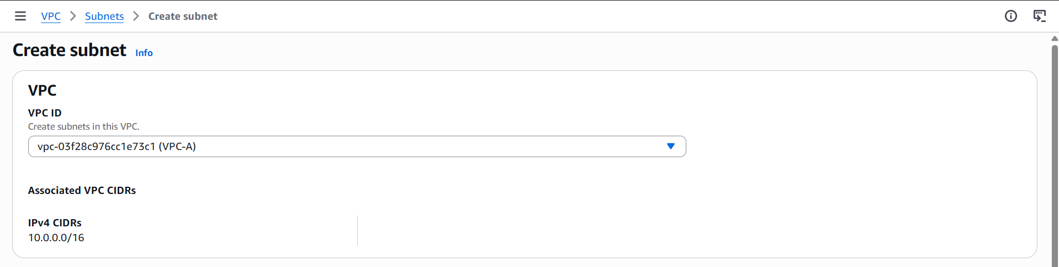
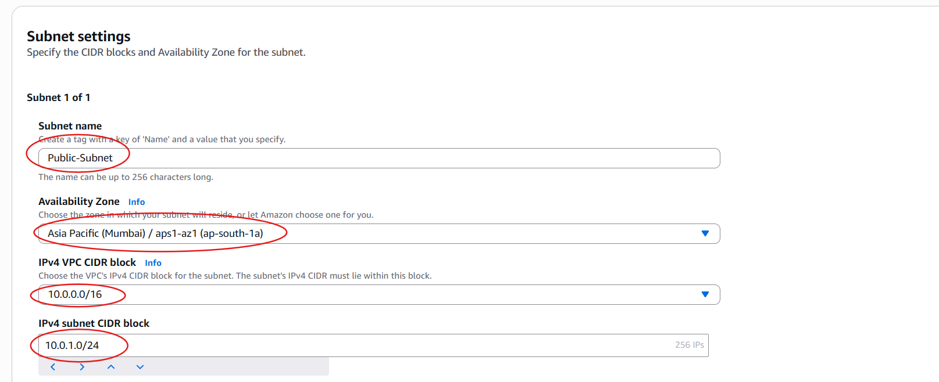
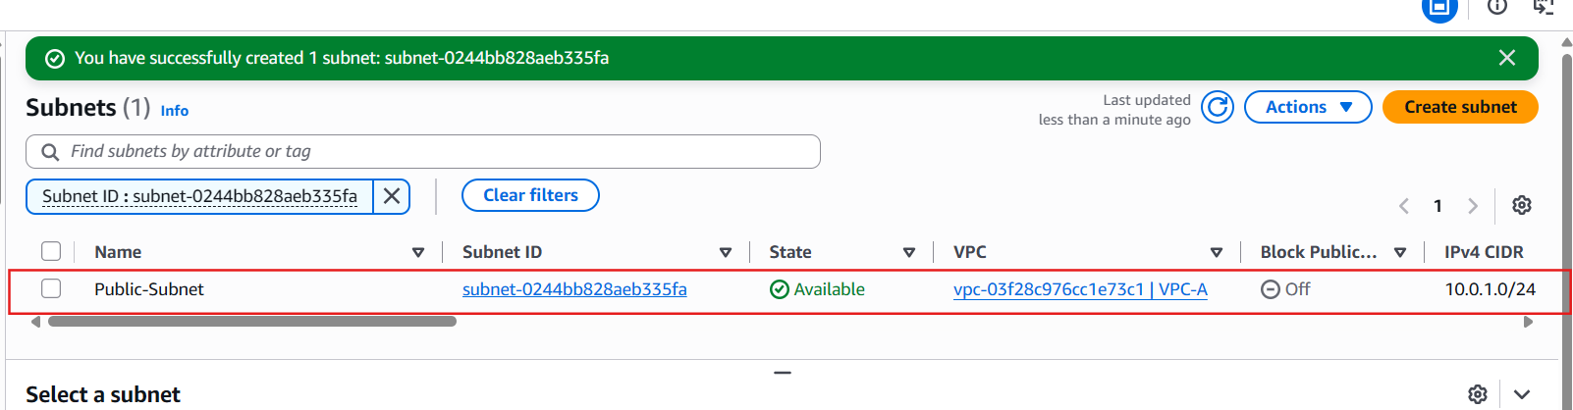

Step 1.4 — Create the Private Subnet
1. Click Create subnet again.
2. VPC ID: select VPC-A.
3. Subnet settings: Subnet name = Private-Subnet; Availability Zone = ap-south-1a (or a different AZ for HA); IPv4 CIDR = 10.0.2.0/24.
4. Click Create subnet.
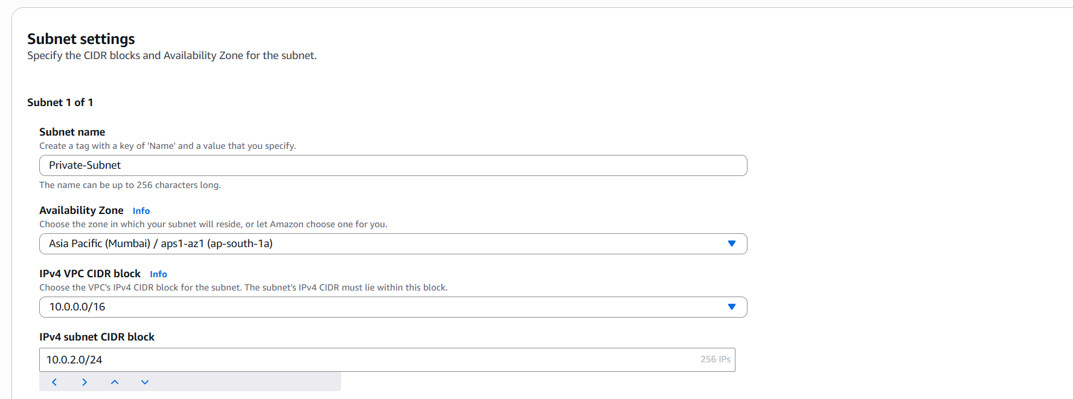
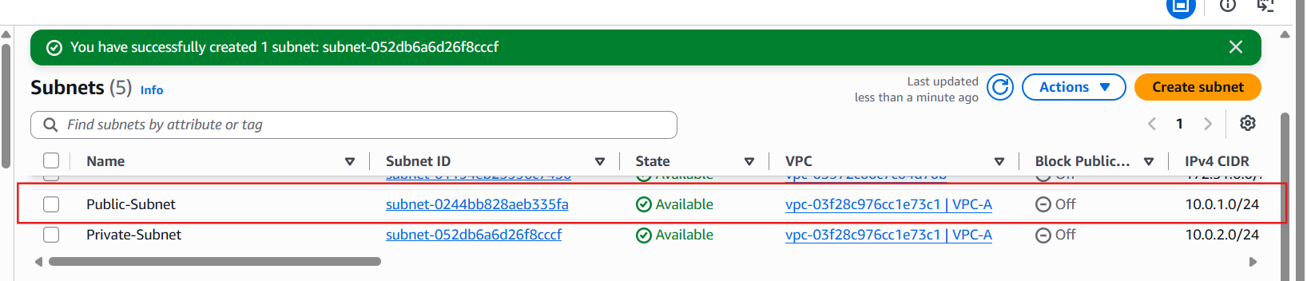

Step 1.5 — Create and Attach an Internet Gateway (IGW)
1. Left pane → Internet Gateways → Create internet gateway.
2. Name tag: VPC-IGW.
3. Click Create internet gateway.
4. On the details page, click Actions → Attach to VPC.
5. Select VPC-A → click Attach internet gateway.
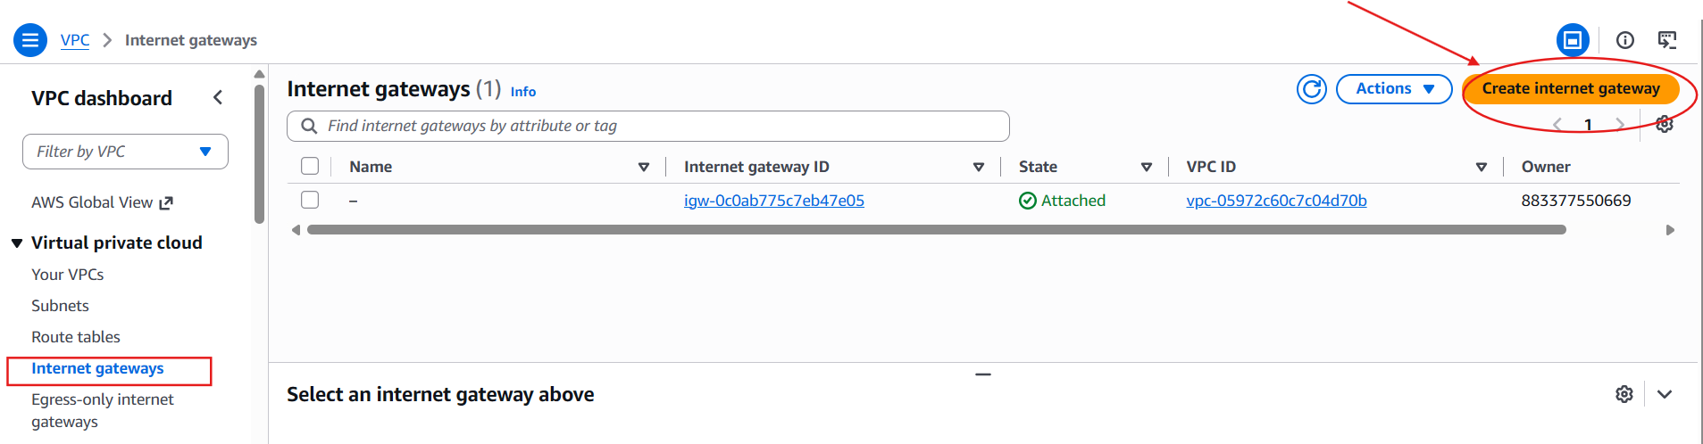
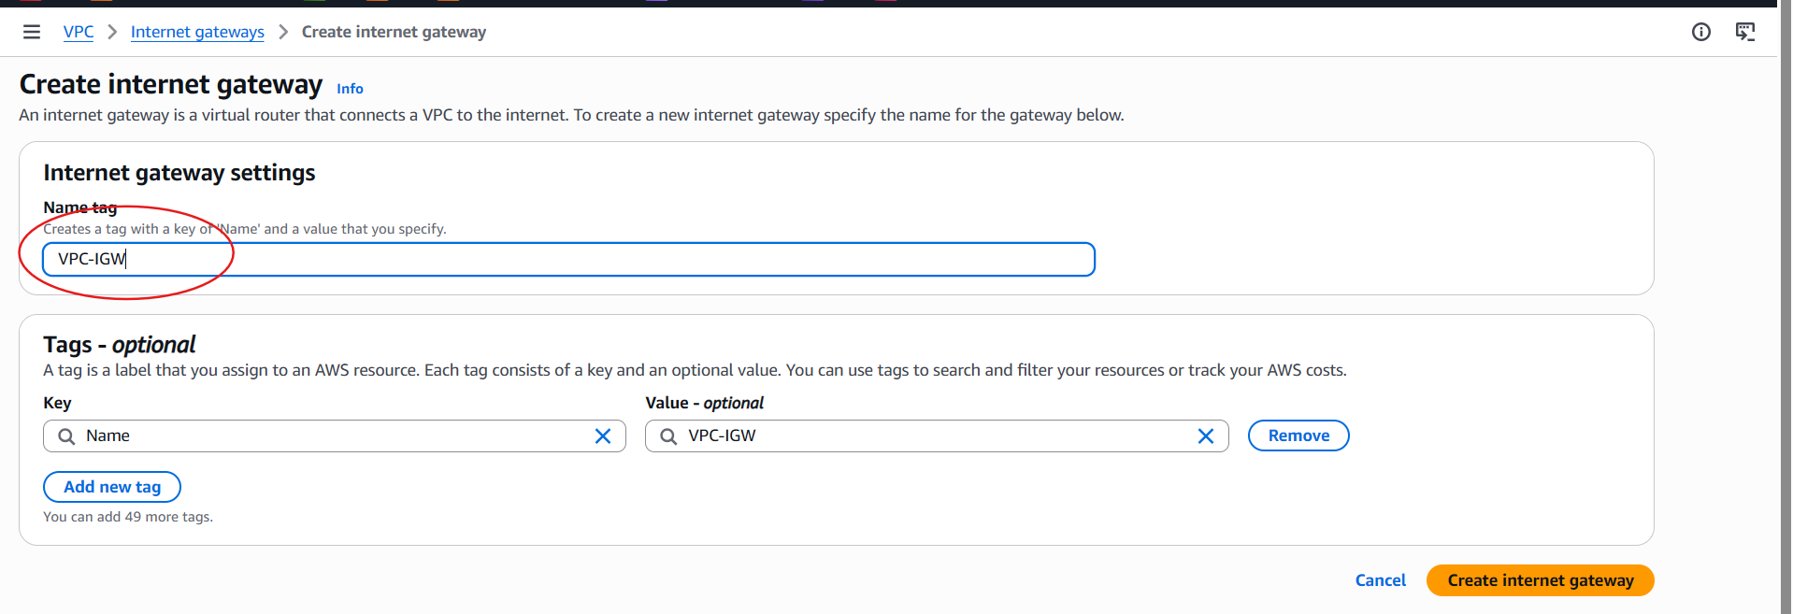
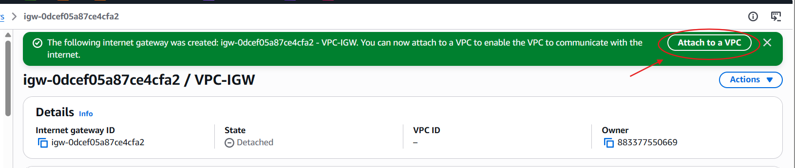
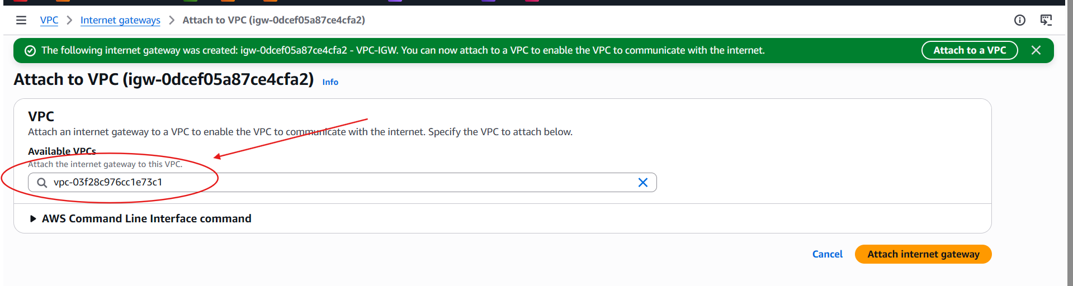
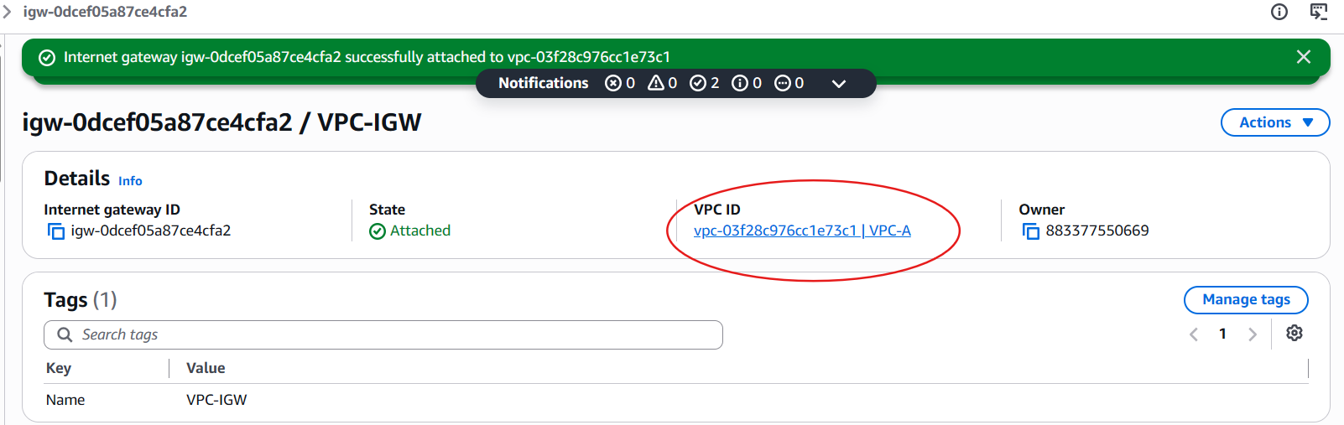

Step 1.6 — Create a Public Route Table
1. Left pane → Route Tables → Create route table.
2. Name tag: Public-RT. VPC: VPC-A.
3. Click Create route table.
4. Select the new route table → Routes tab → Edit routes.
5. Click Add route: Destination = 0.0.0.0/0; Target = Internet Gateway → select VPC-IGW.
6. Click Save changes.
7. Go to Subnet associations tab → Edit subnet associations.
8. Check Public-Subnet → Save associations.
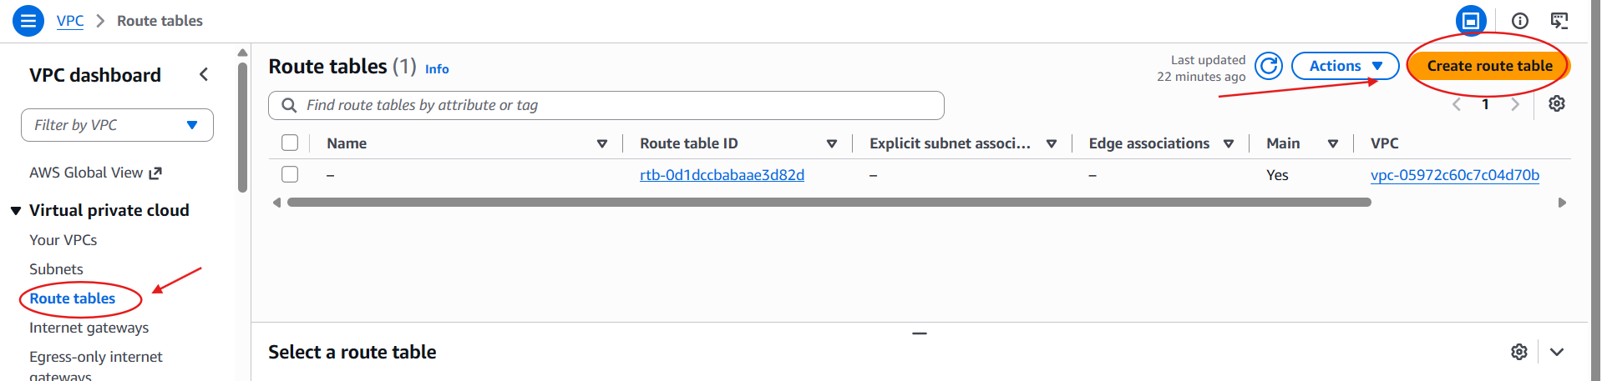
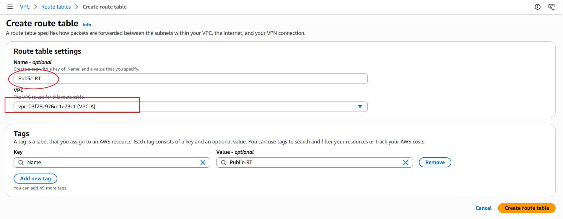
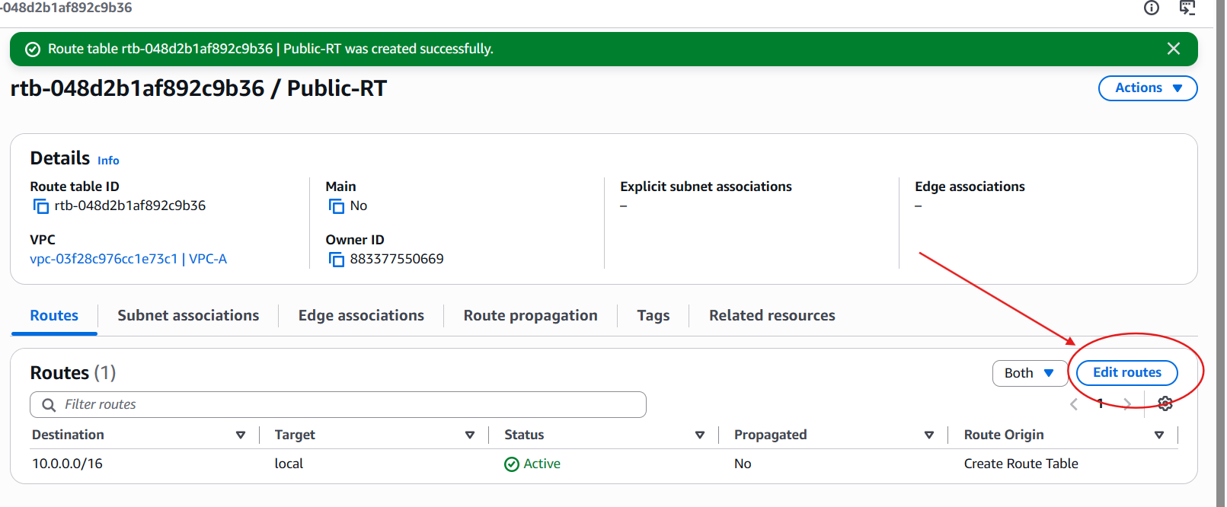
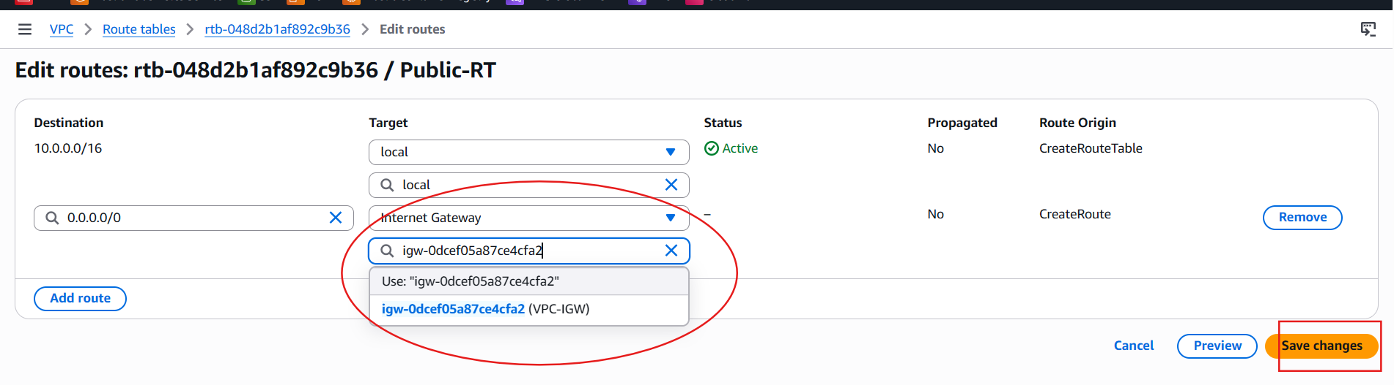
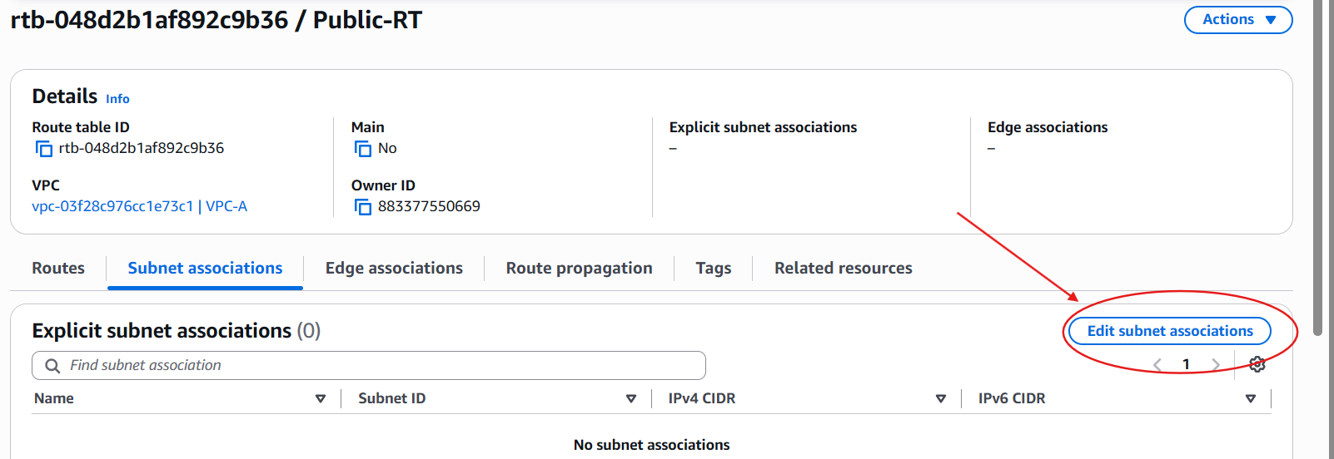
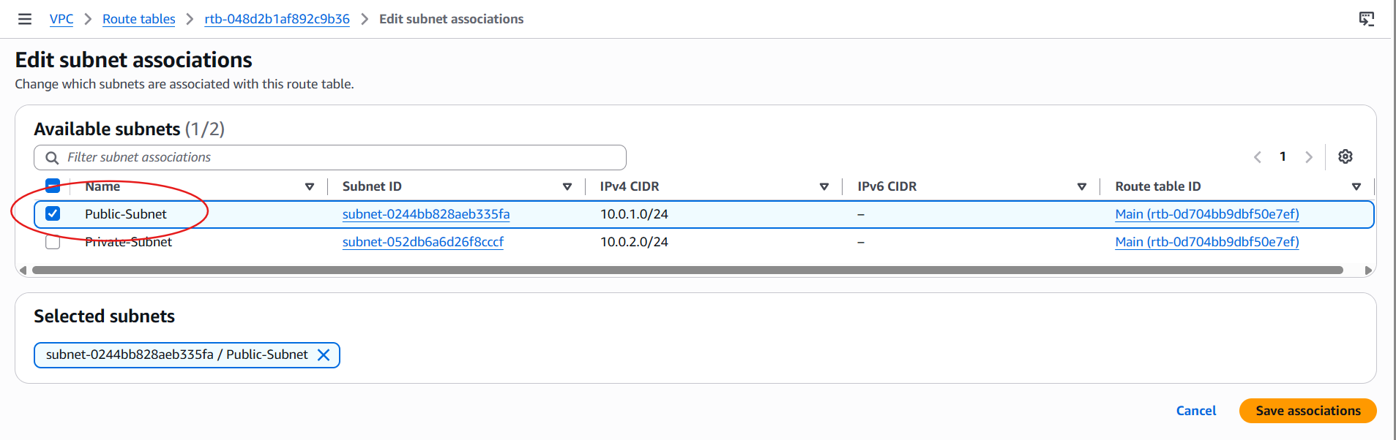

Step 1.7 — Create the Private Route Table
1. Create route table → Name: Private-RT, VPC: VPC-A → Create.
2. Go to Subnet associations → Edit subnet associations → check Lab-Private-Subnet → Save associations.
3. Leave the default local route only (no 0.0.0.0/0 route) — this keeps it private. Add a NAT Gateway route here in Step 1.8 if outbound internet is needed.
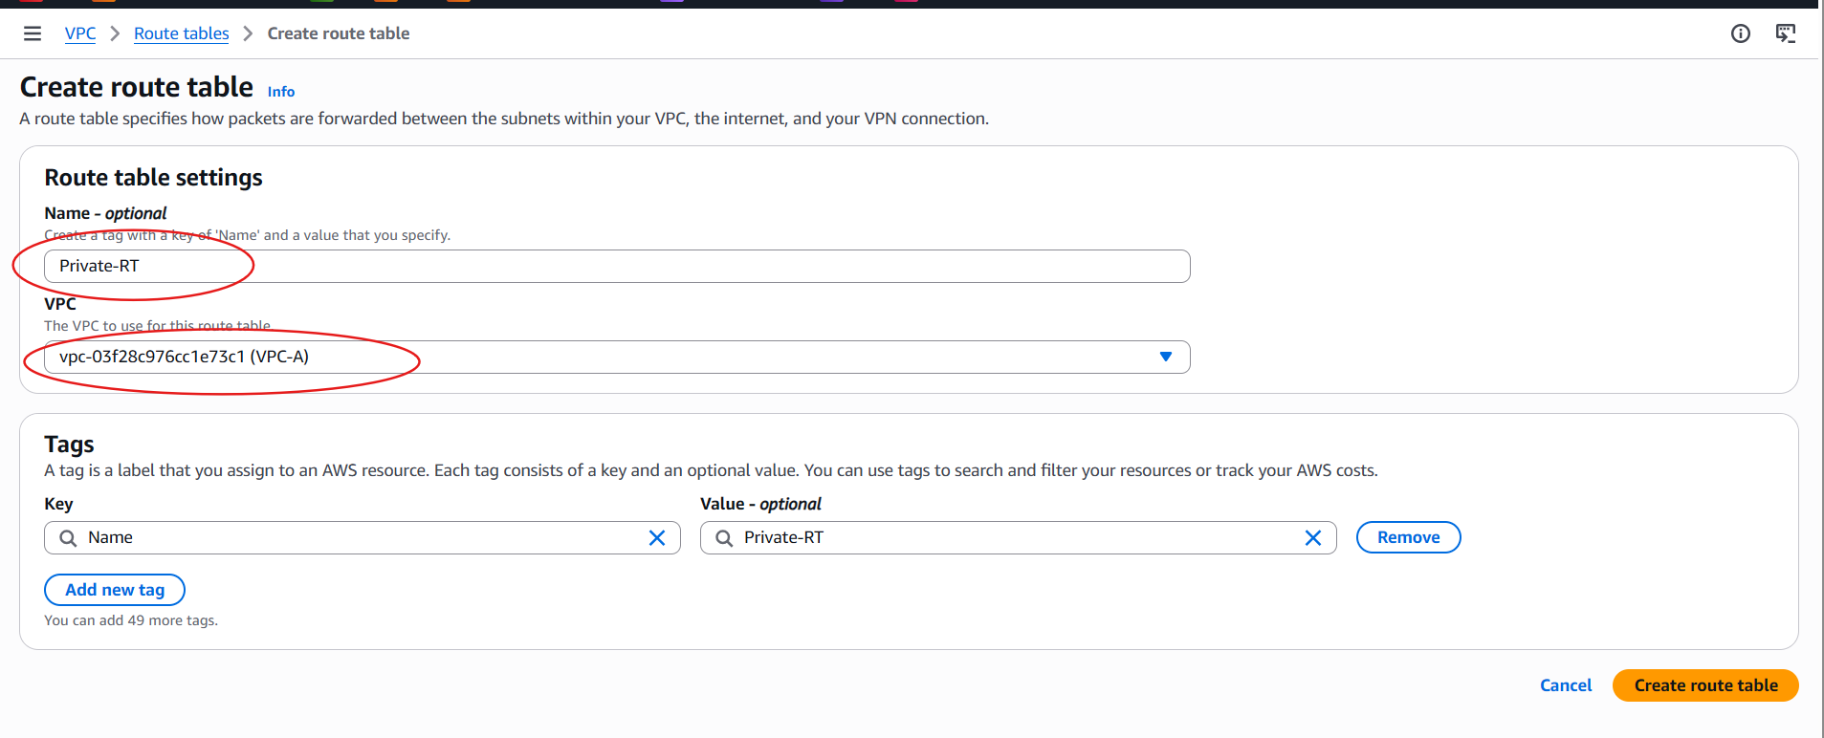
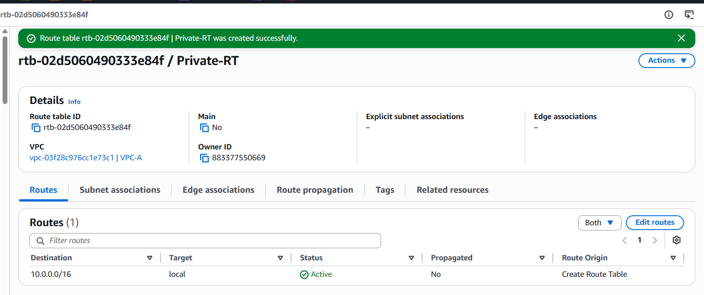
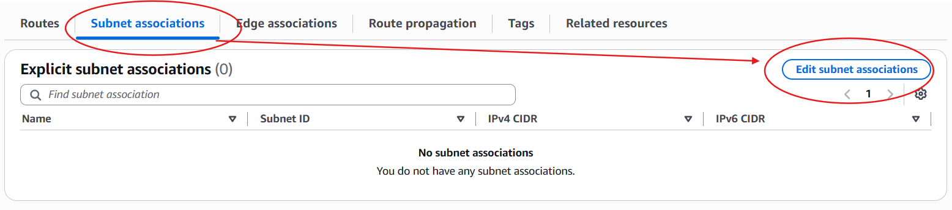
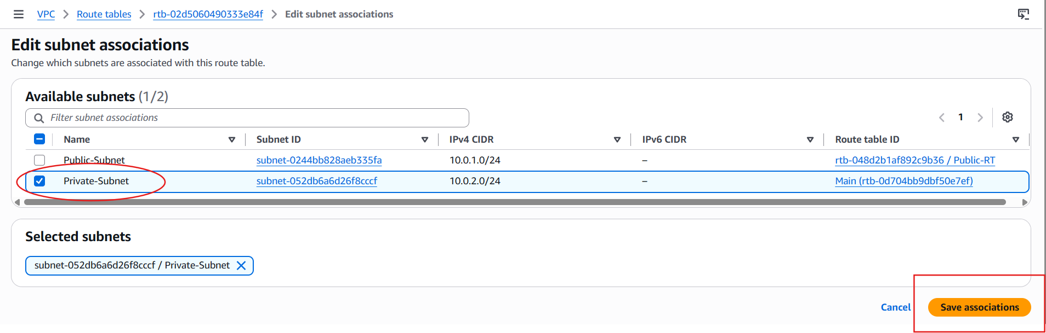

TASK 2: Enable VPC Peering — Cross-Region
Goal: Peer VPC-A (ap-south-1, 10.0.0.0/16) with a new VPC Lab-VPC-B in us-east-1 (10.1.0.0/16).

Step 2.1 — Create the Second VPC in a Different Region
1. Switch region (top-right) to US East (N. Virginia) us-east-1.
2. VPC Console → Your VPCs → Create VPC.
3. VPC only, Name: VPC-B, IPv4 CIDR: 10.1.0.0/16 → Create VPC.
4. Create a subnet, e.g., 10.1.1.0/24 in us-east-1a, named VPC-B-Subnet, for connectivity testing later.
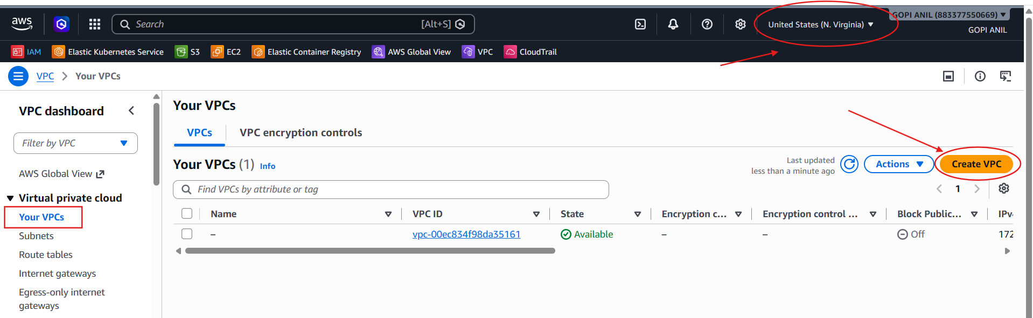
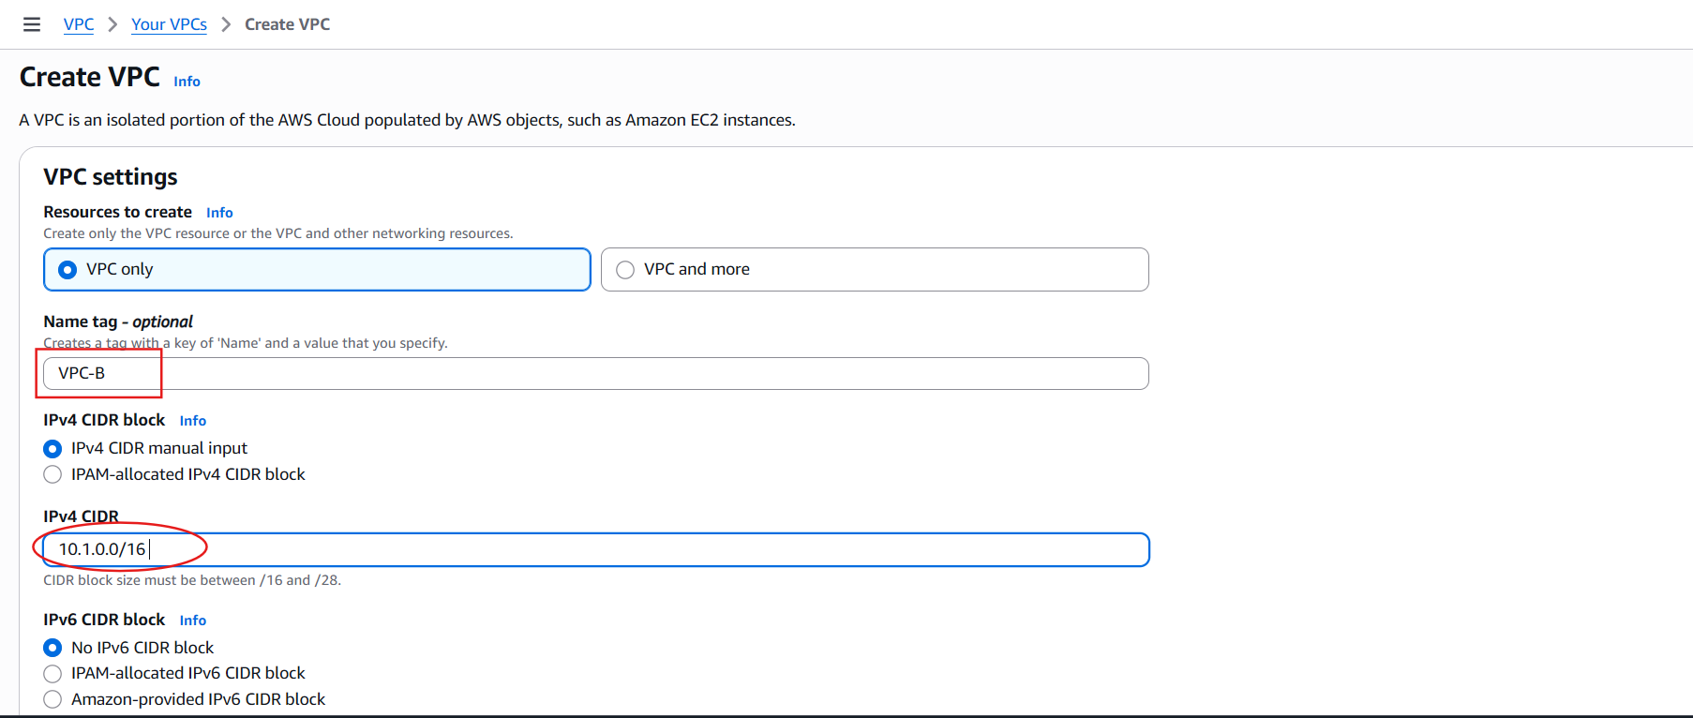

Step 2.2 — Initiate the Peering Connection (from the Requester Region)
1. Switch region back to ap-south-1 (Mumbai) — this is the requester side.
2. VPC Console → left pane → Peering Connections → Create peering connection.
3. Peering connection name tag: VPC-A-to-B-CrossRegion.
4. VPC (Requester): VPC-A (10.0.0.0/16). Account: My account.
5. Region: select Another Region → choose us-east-1.
6. VPC (Accepter): enter the VPC ID of VPC-B (copy from the us-east-1 console, e.g., vpc-0abc123...).
7. Click Create peering connection. Status shows Pending Acceptance.
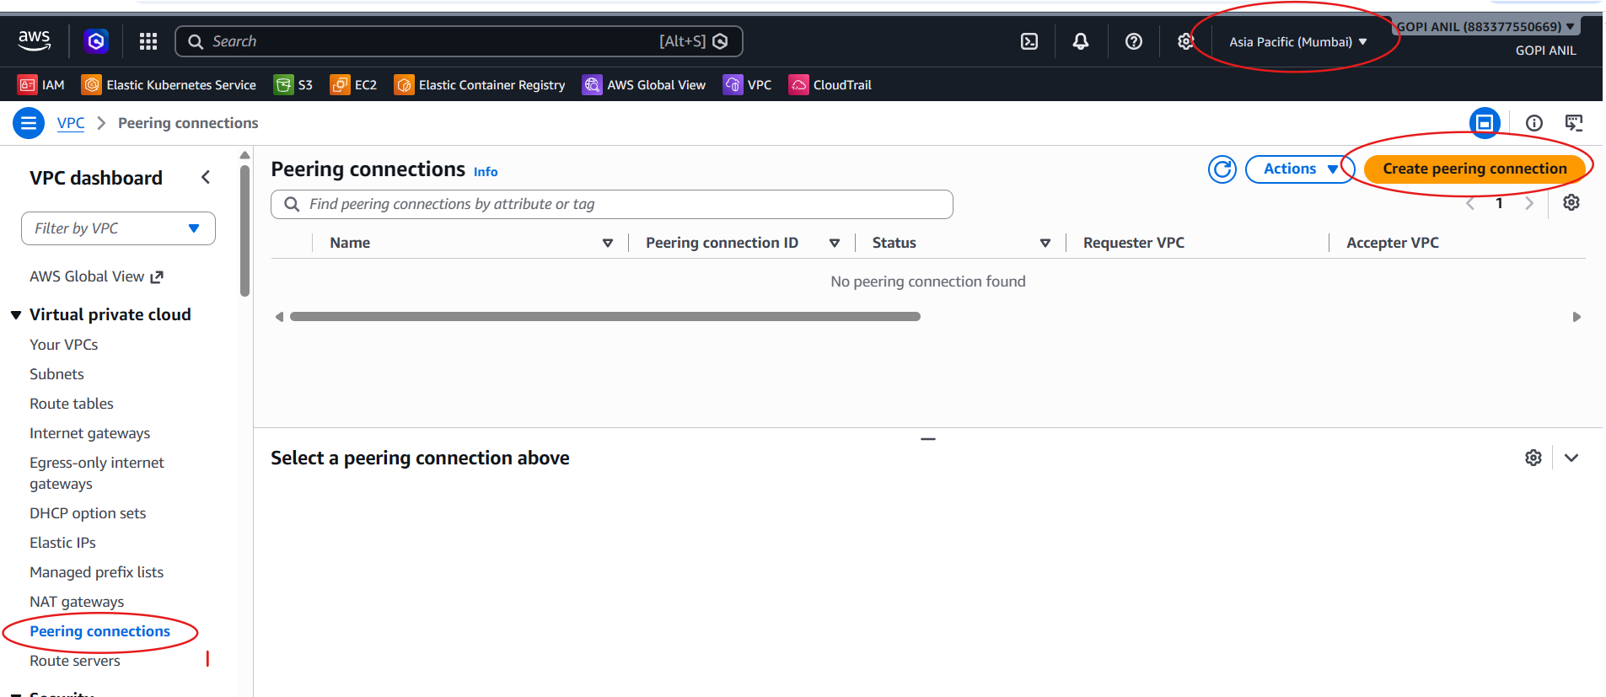
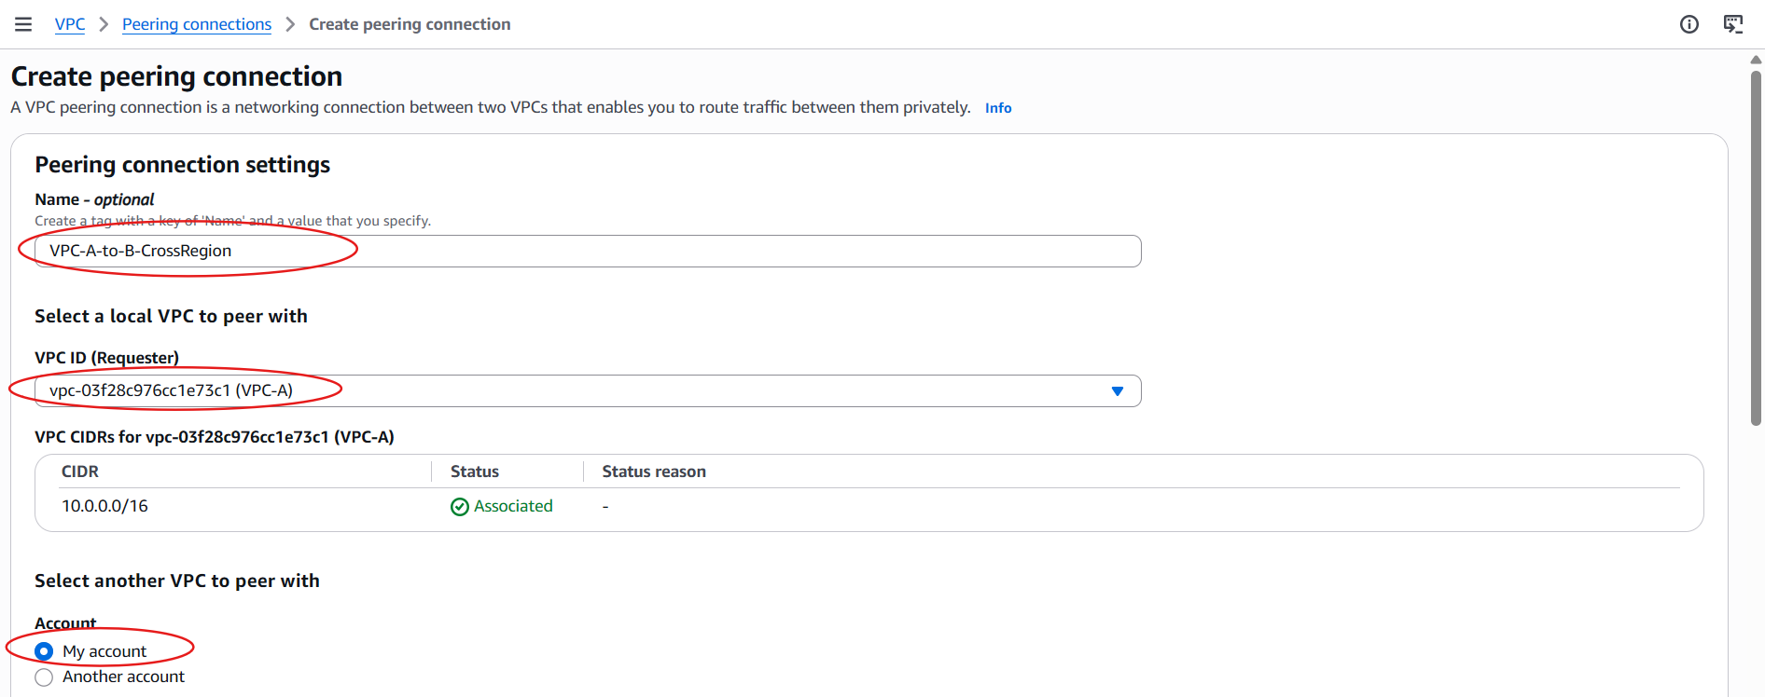
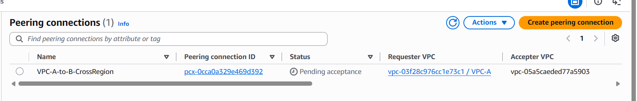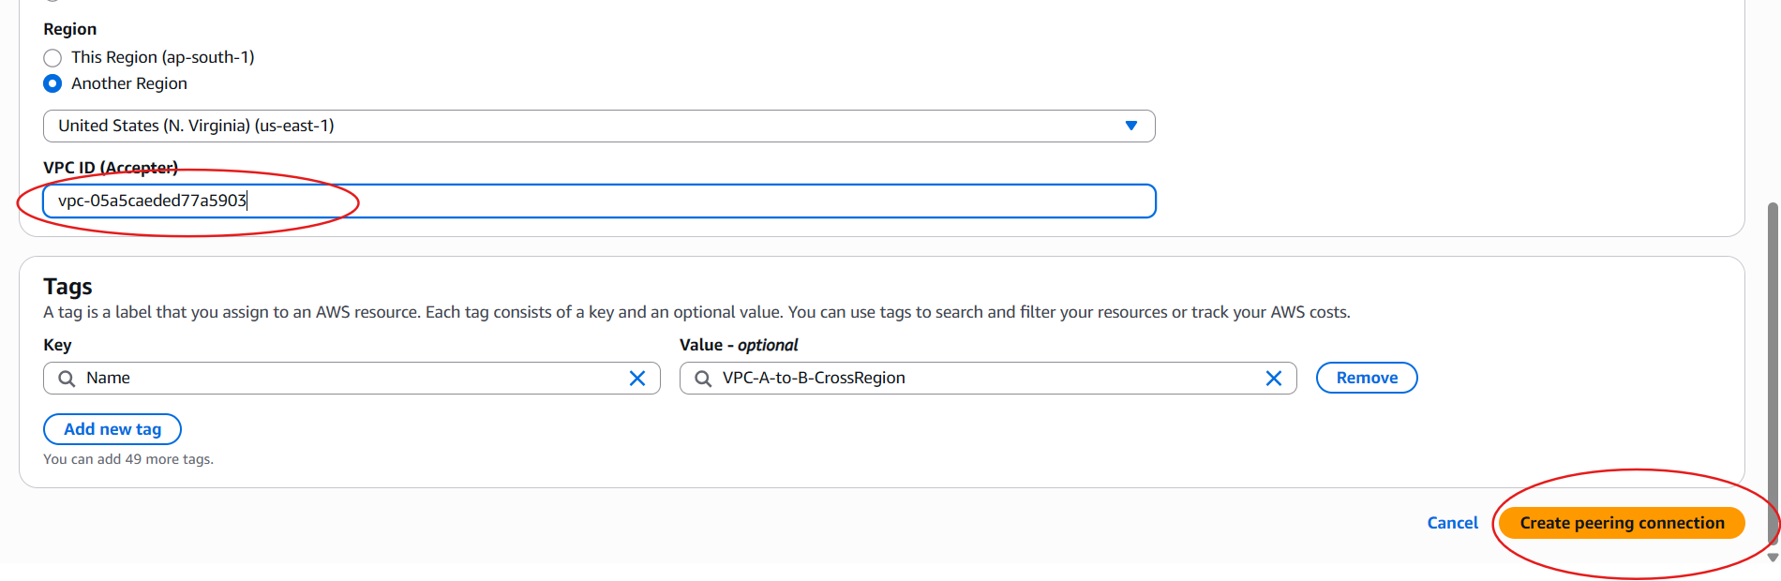

Step 2.3 — Accept the Peering Connection (in the Accepter Region)
1. Switch region to us-east-1.
2. VPC Console → Peering Connections.
3. Select the request showing status Pending Acceptance → Actions → Accept request.
4. Confirm in the dialog → Accept request. Status changes to Active.
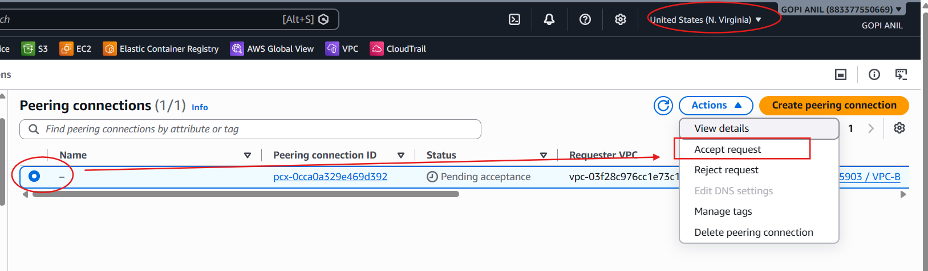
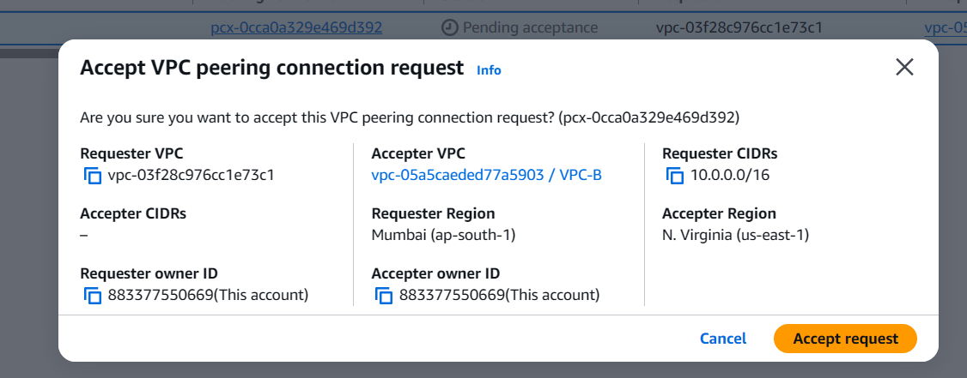
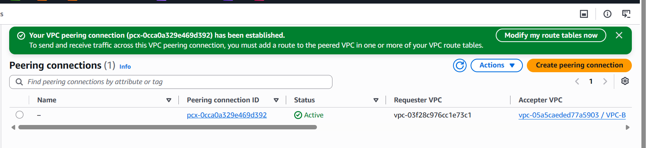

Step 2.4 — Update Route Tables on Both Sides
In ap-south-1 (VPC-A side):
1. VPC Console (ap-south-1) → Route Tables → select Public-RT (and Private-RT if needed).
2. Routes tab → Edit routes → Add route: Destination = 10.1.0.0/16; Target = Peering Connection → select pcx-xxxxxxxx.
3. Save changes. Repeat for each route table that needs cross-VPC access.
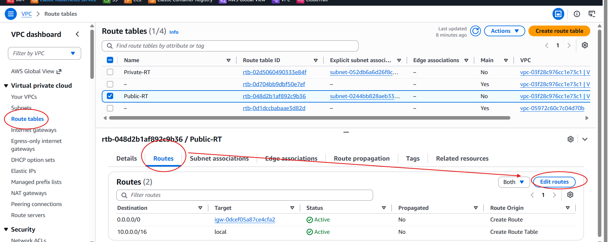
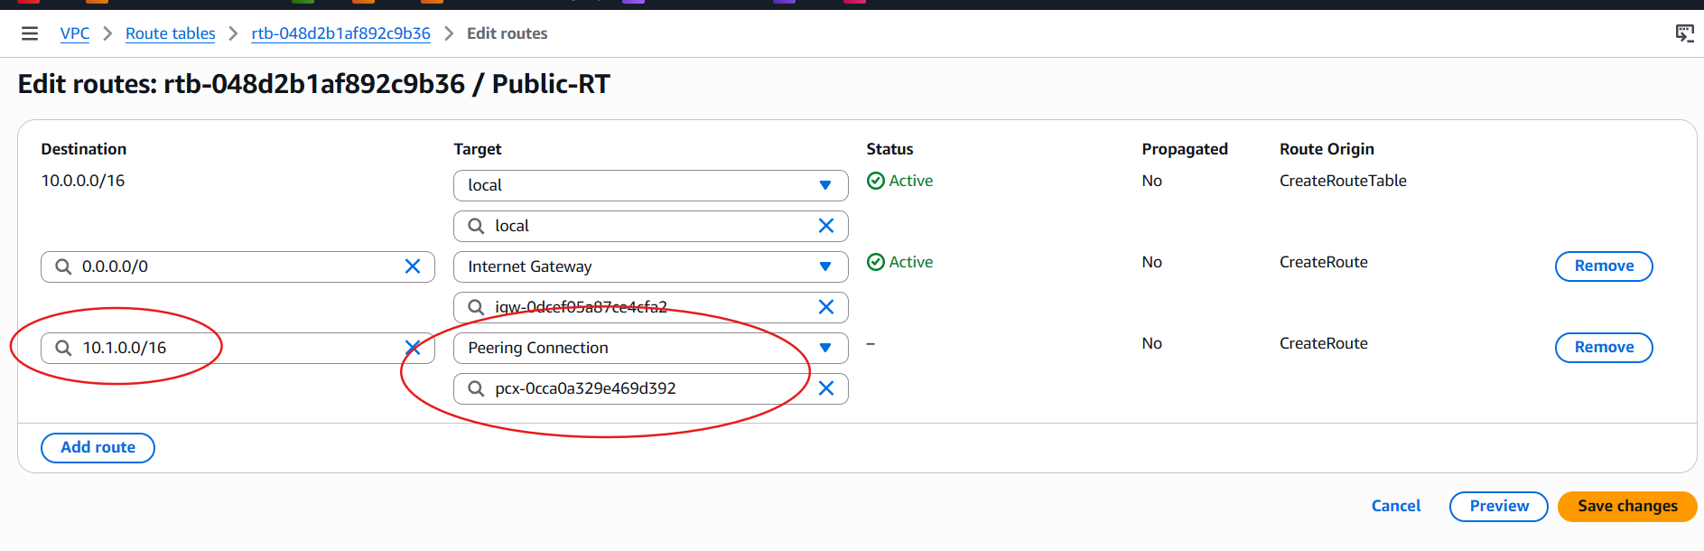
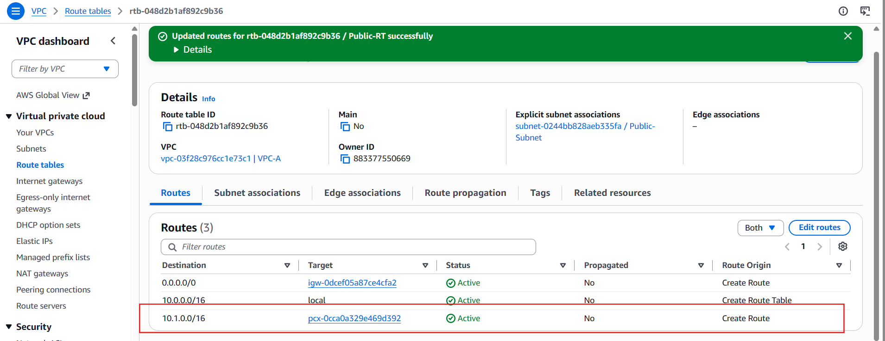

In us-east-1 (VPC-B side):
4. Switch region to us-east-1 → Route Tables → select the route table associated with VPC-B-Subnet.
5. Edit routes → Add route: Destination = 10.0.0.0/16; Target = Peering Connection → select the same pcx-xxxxxxxx.
6. Save changes.

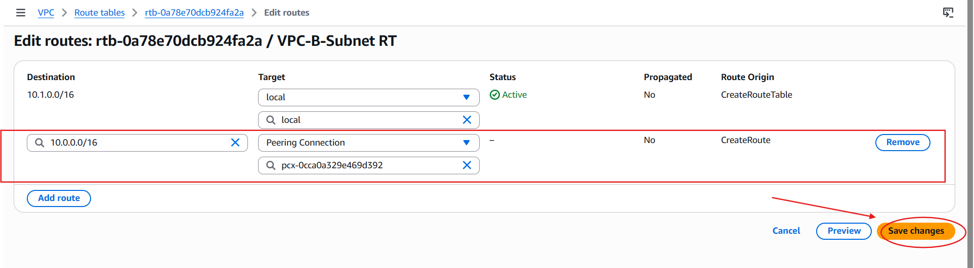
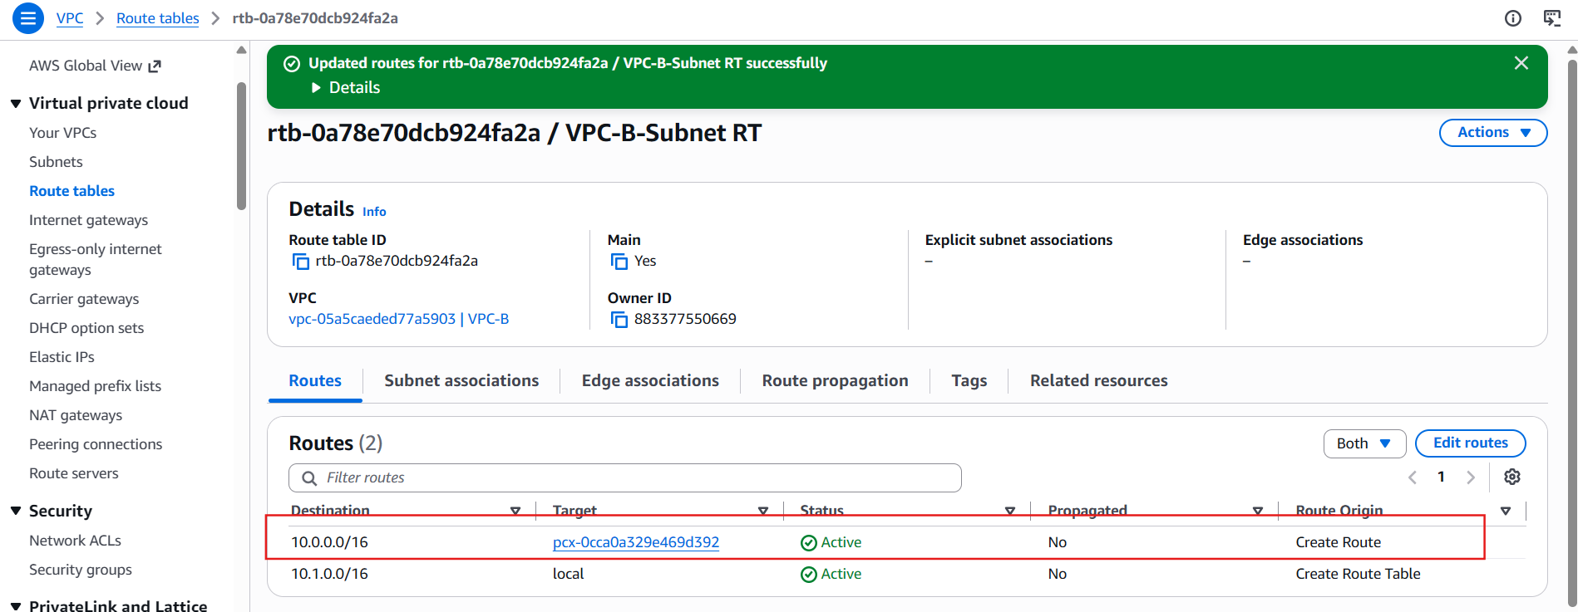

Step 2.5 — Update Security Groups
1. On instances in VPC-A, edit the Security Group Inbound rules → allow traffic (e.g., ICMP or specific port) from source 10.1.0.0/16.
2. On instances in VPC-B, edit the Security Group Inbound rules → allow traffic from source 10.0.0.0/16.
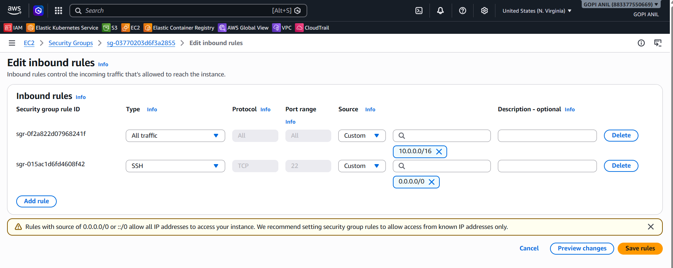
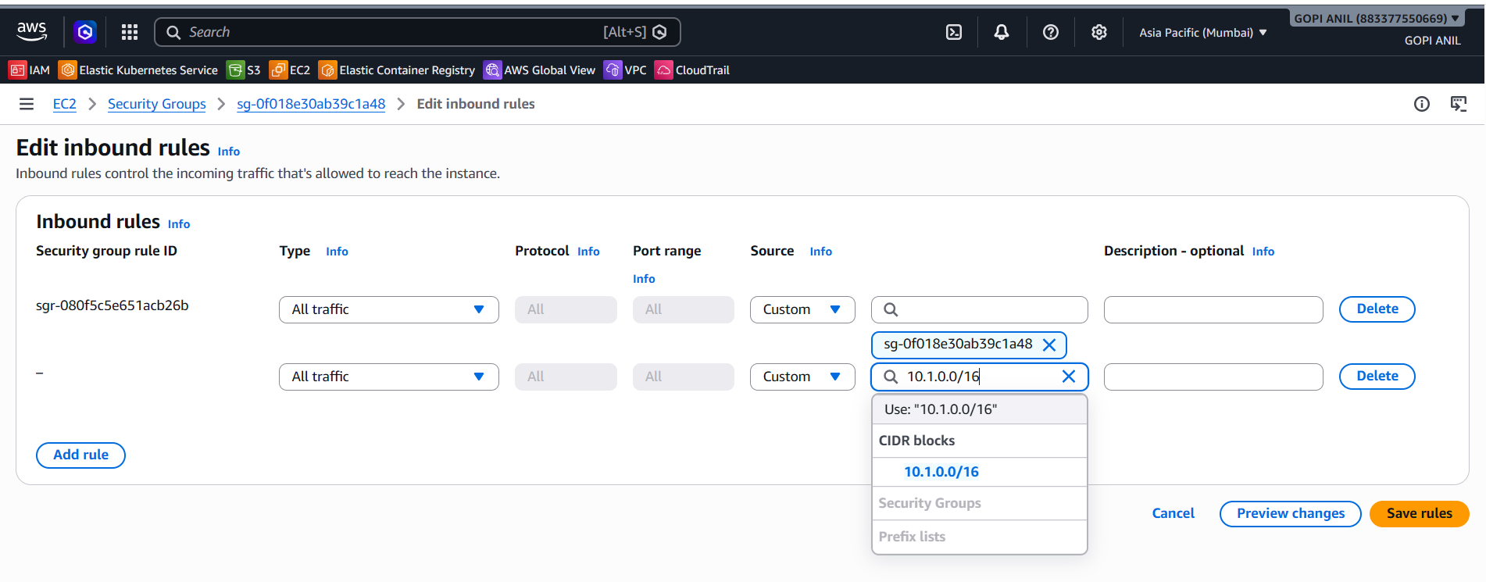

Step 2.6 — Test Connectivity
1. Launch/EC2 Connect into an instance in Lab-VPC-A public subnet.
2. Run: ping <private-IP-of-instance-in-VPC-B> (ICMP must be allowed in SG/NACL).
3. A successful reply confirms cross-region peering works.
✅ Task 2 Complete: Cross-region peering established between Lab-VPC-A (Mumbai) and Lab-VPC-B (N. Virginia).
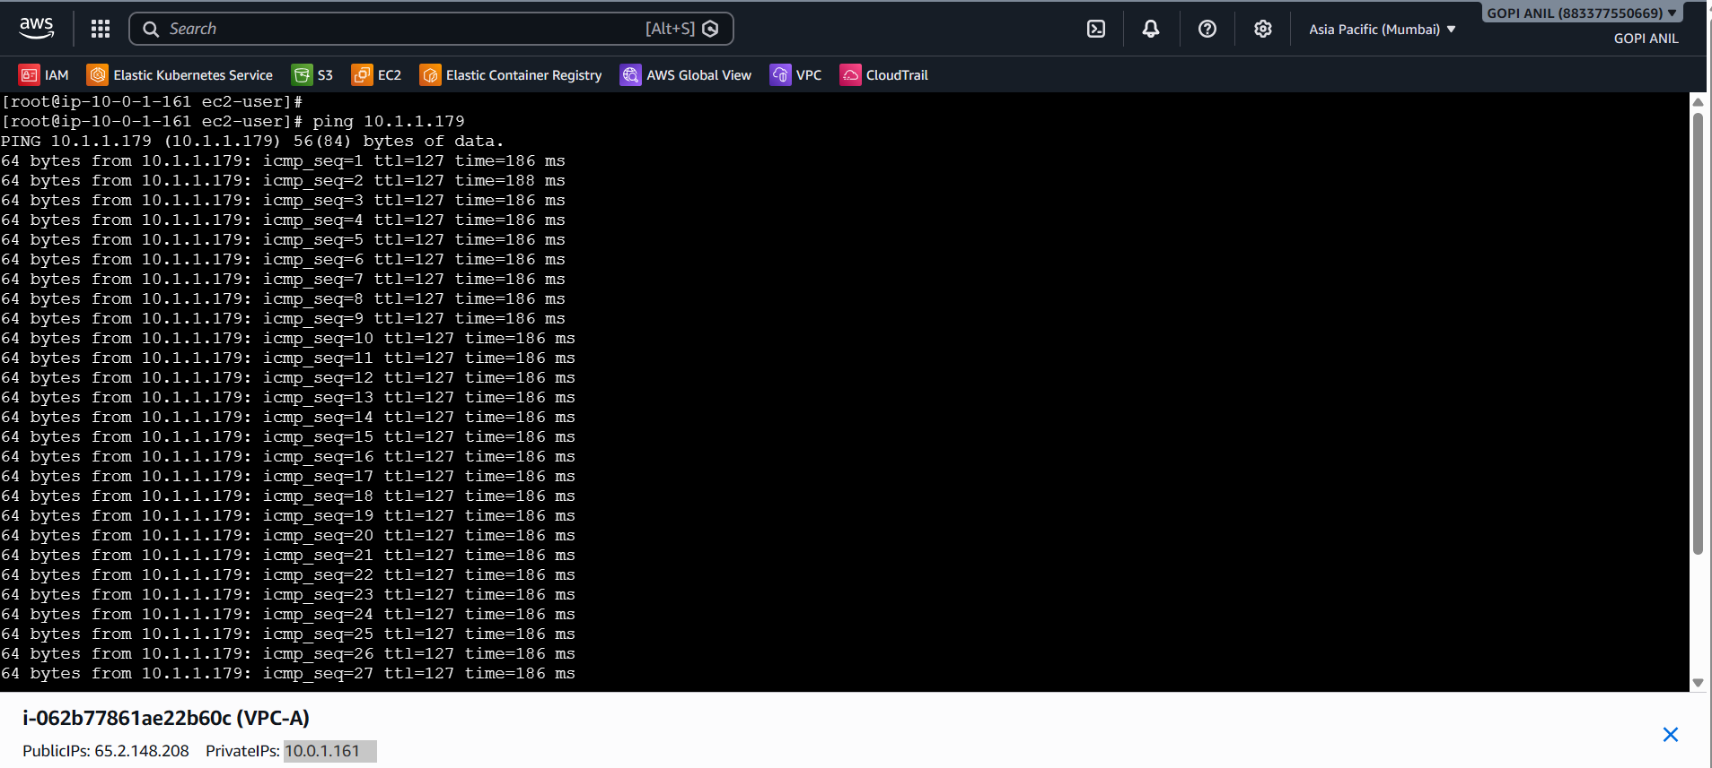
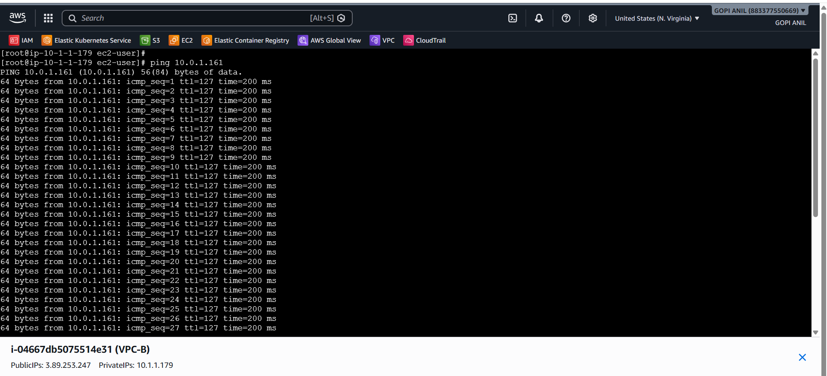

TASK 3: Enable VPC Peering — Cross-Account
Goal: Peer VPC-A (your account, ap-south-1) with VPC-C in your friend's AWS account (same or different region).

Step 3.1 — Friend Creates a VPC in Their Account
Ask your friend to:
1. Log in to their own AWS Console.
2. VPC Console → Create VPC → Name: VPC-C, CIDR: 10.2.0.0/16 (must not overlap with VPC-A's CIDR).
3. Optionally create a subnet, e.g. 10.2.1.0/24.
4. Share with you: their AWS Account ID (top-right account dropdown, or IAM console), the VPC ID of VPC-C, and the Region they created it in.
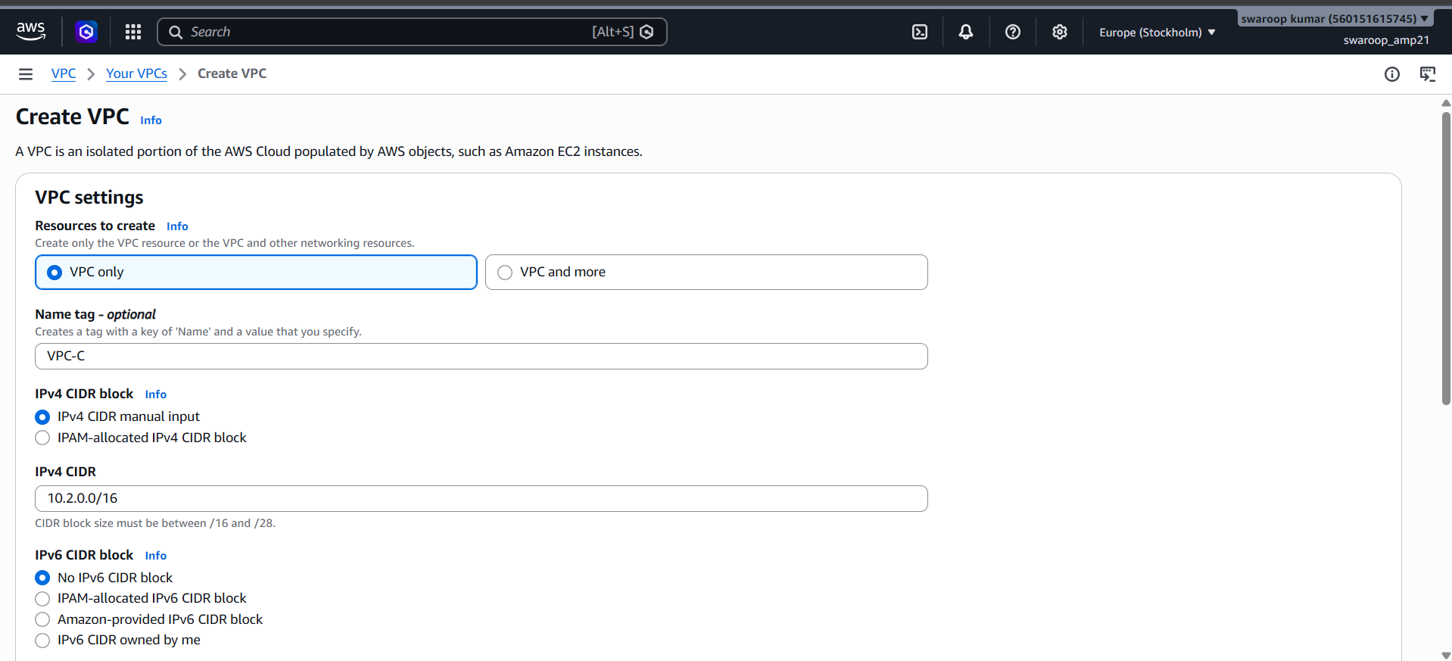
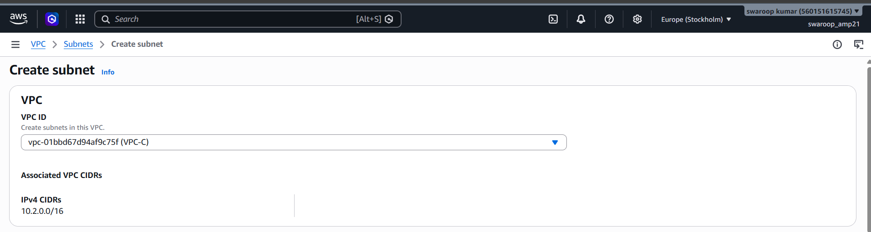
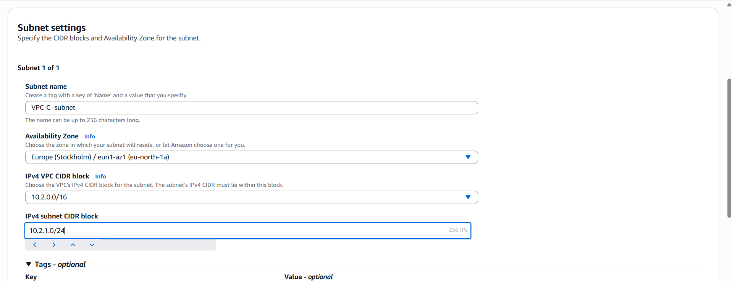

Step 3.2 — You (Requester) Create the Peering Connection
1. In your AWS Console, go to region ap-south-1 (or match your friend's region).
2. VPC Console → Peering Connections → Create peering connection.
3. Name tag: VPC-A-to-C-CrossAccount.
4. VPC (Requester): -VPC-A. Account: select Another account.
5. Account ID: enter your friend's 12-digit AWS Account ID.
6. Region: select This Region if same region, or Another Region if different.
7. VPC (Accepter): enter the VPC ID your friend shared, e.g., vpc-0friendvpc123.
8. Click Create peering connection. Status: Pending Acceptance.
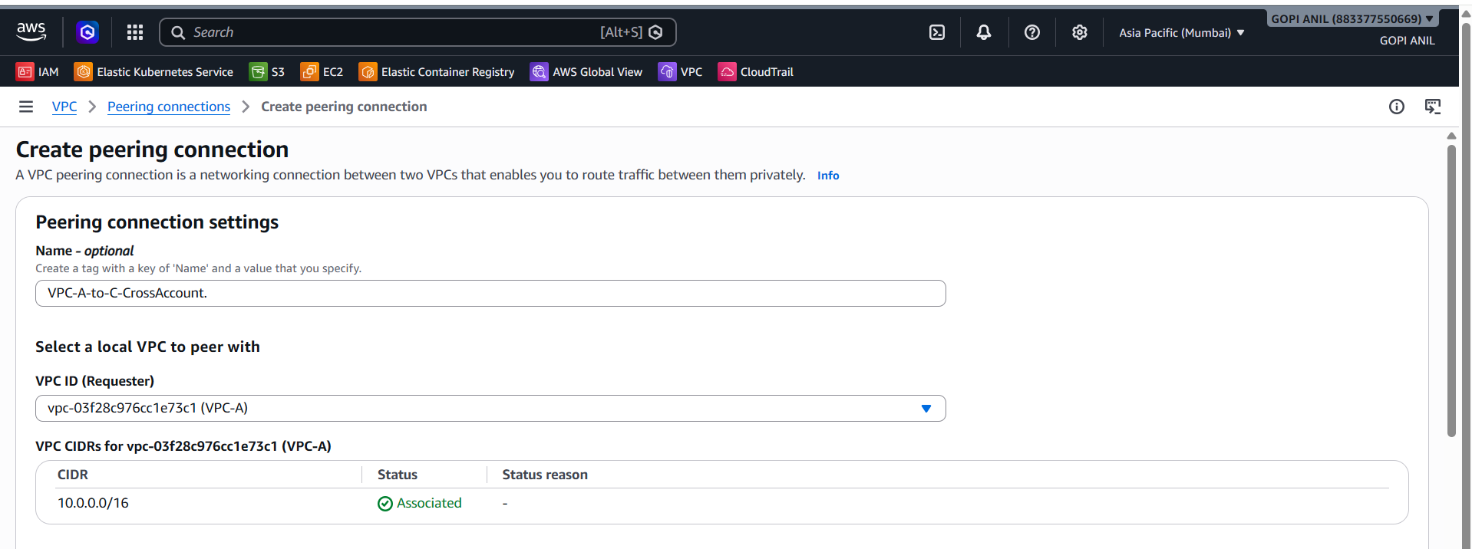
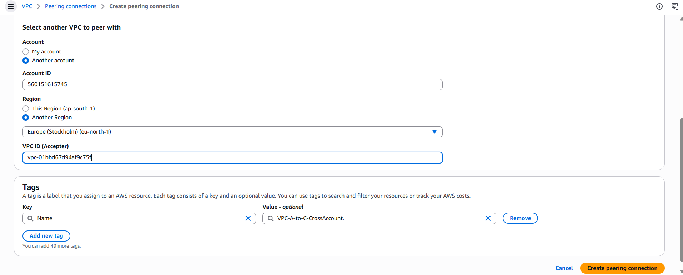
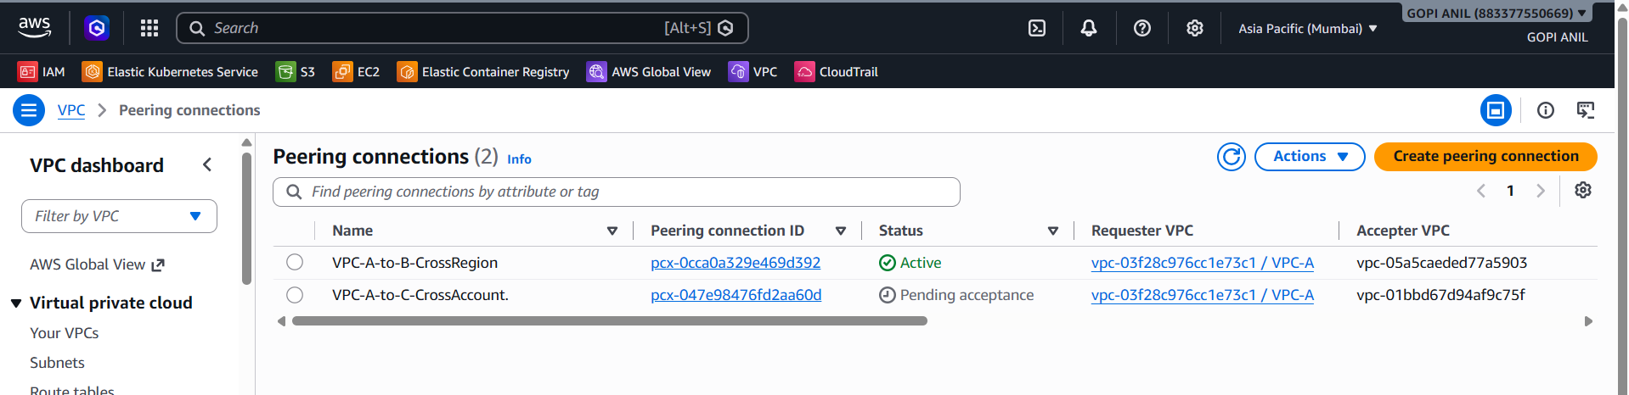

Step 3.3 — Friend Accepts the Request (in Their Account)
Ask your friend to:
1. Log in to their AWS Console, same region as the peering request.
2. VPC Console → Peering Connections.
3. Locate the incoming request with status Pending Acceptance, Requester = your Account ID.
4. Select it → Actions → Accept Request → confirm.
5. Status becomes Active in both accounts.
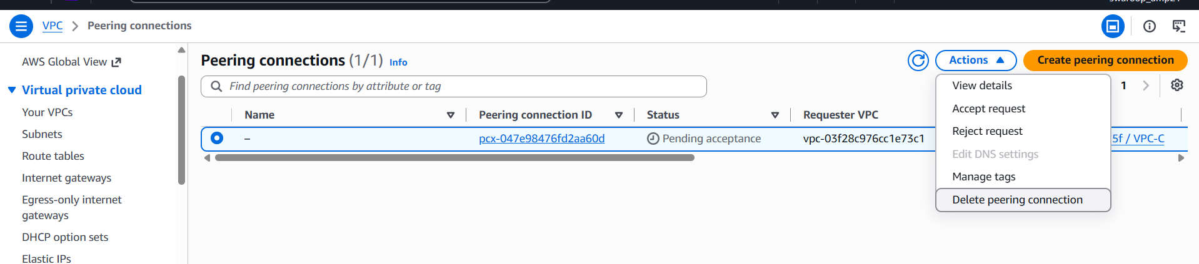
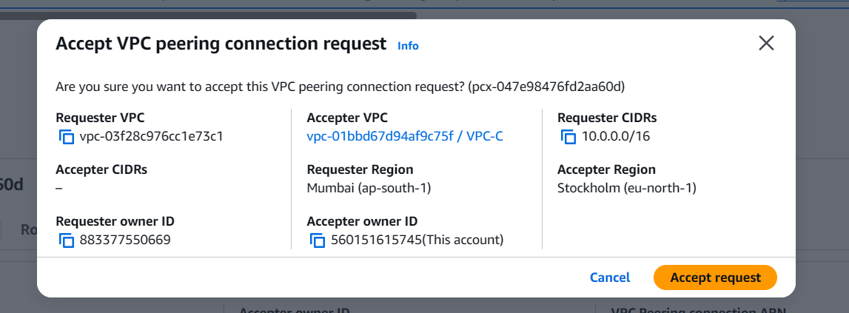
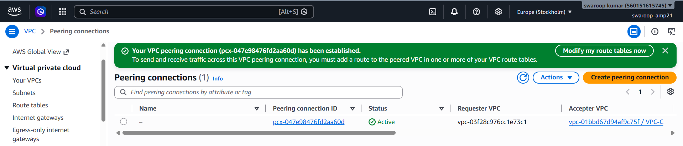

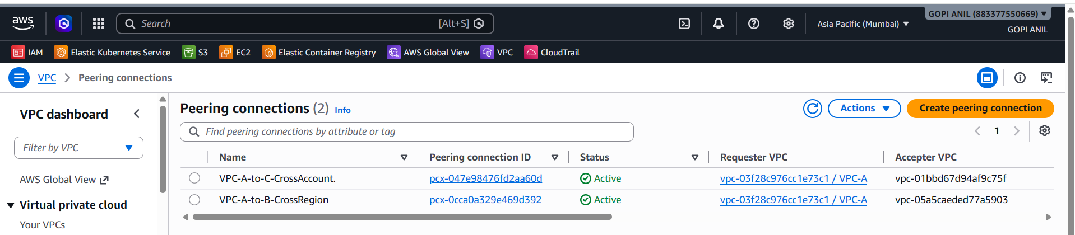

Step 3.4 — Update Route Tables on Both Sides
Your side (Account A, VPC-A):
1. Route Tables → Public-RT → Edit routes → Add route: Destination = 10.2.0.0/16; Target = Peering Connection pcx-xxxxxxxx.
2. Save changes.
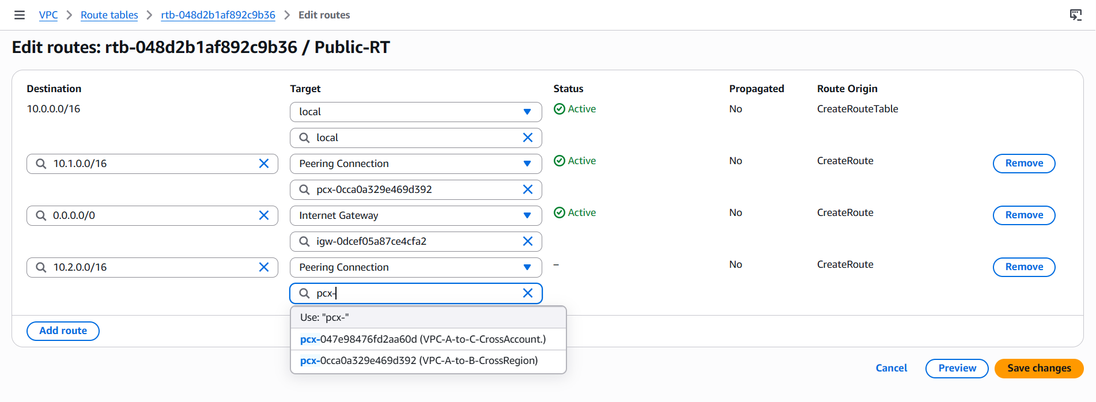

Friend's side (Account C, VPC-C) — ask friend to:
3. Route Tables → select their subnet's route table → Edit routes → Add route: Destination = 10.0.0.0/16; Target = the same peering connection ID.
4. Save changes.
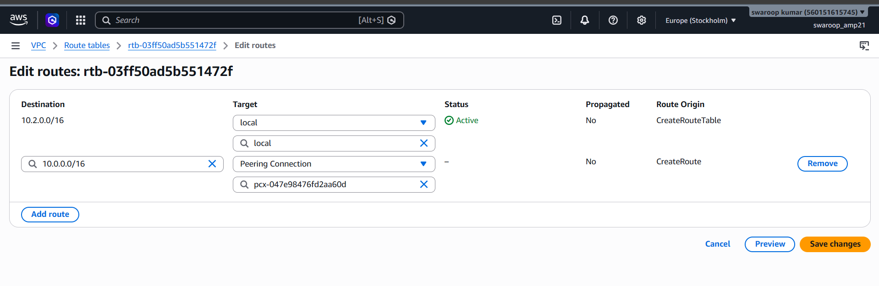

Step 3.5 — Update Security Groups on Both Sides
1. Your instances' SG: allow inbound from 10.2.0.0/16 for required ports.
2. Friend's instances' SG: allow inbound from 10.0.0.0/16 for required ports.
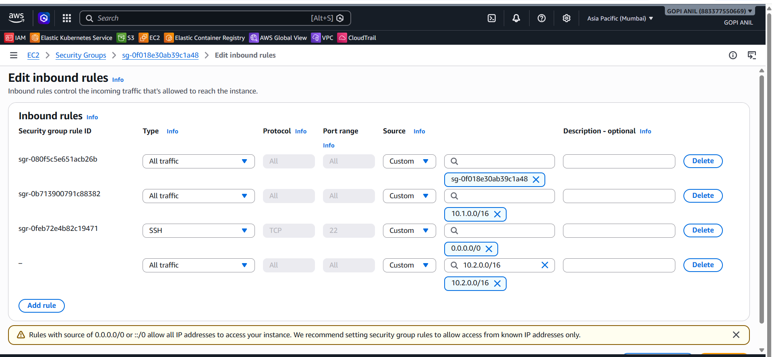
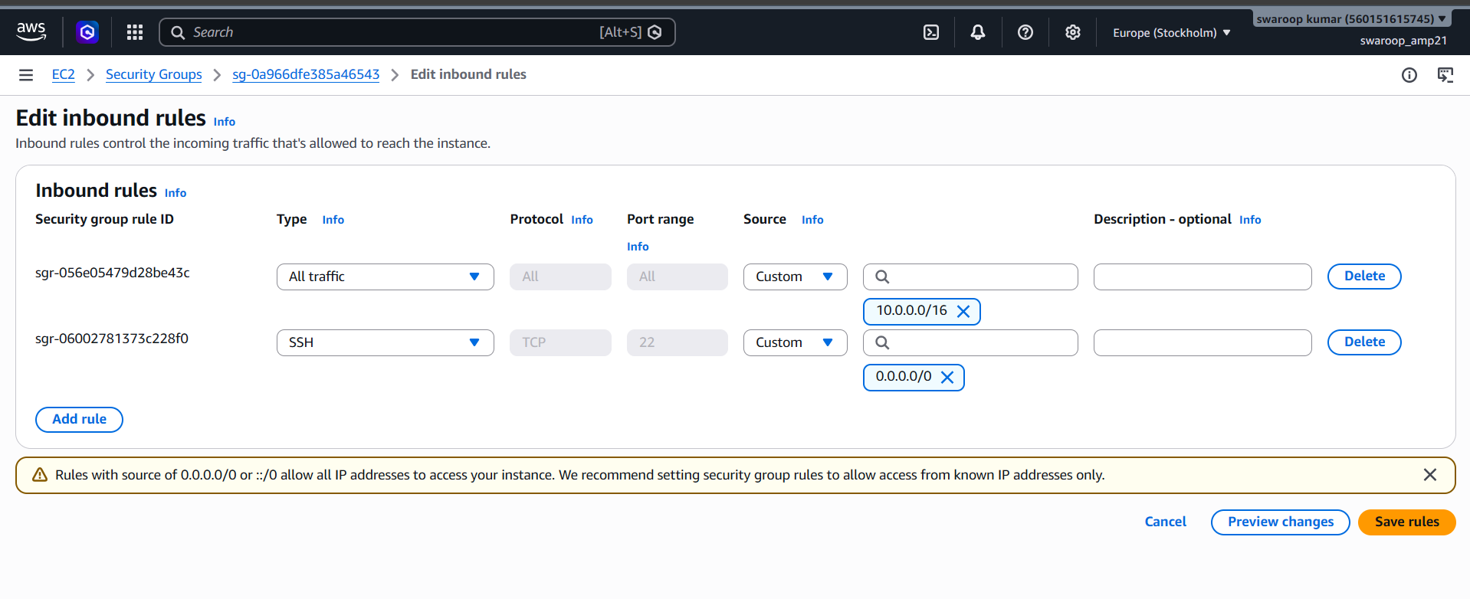

Step 3.7 — Test Connectivity
1. From an EC2 instance in Lab-VPC-A, ping or curl the private IP of an instance in Lab-VPC-C.
2. A successful response confirms cross-account peering is functional.
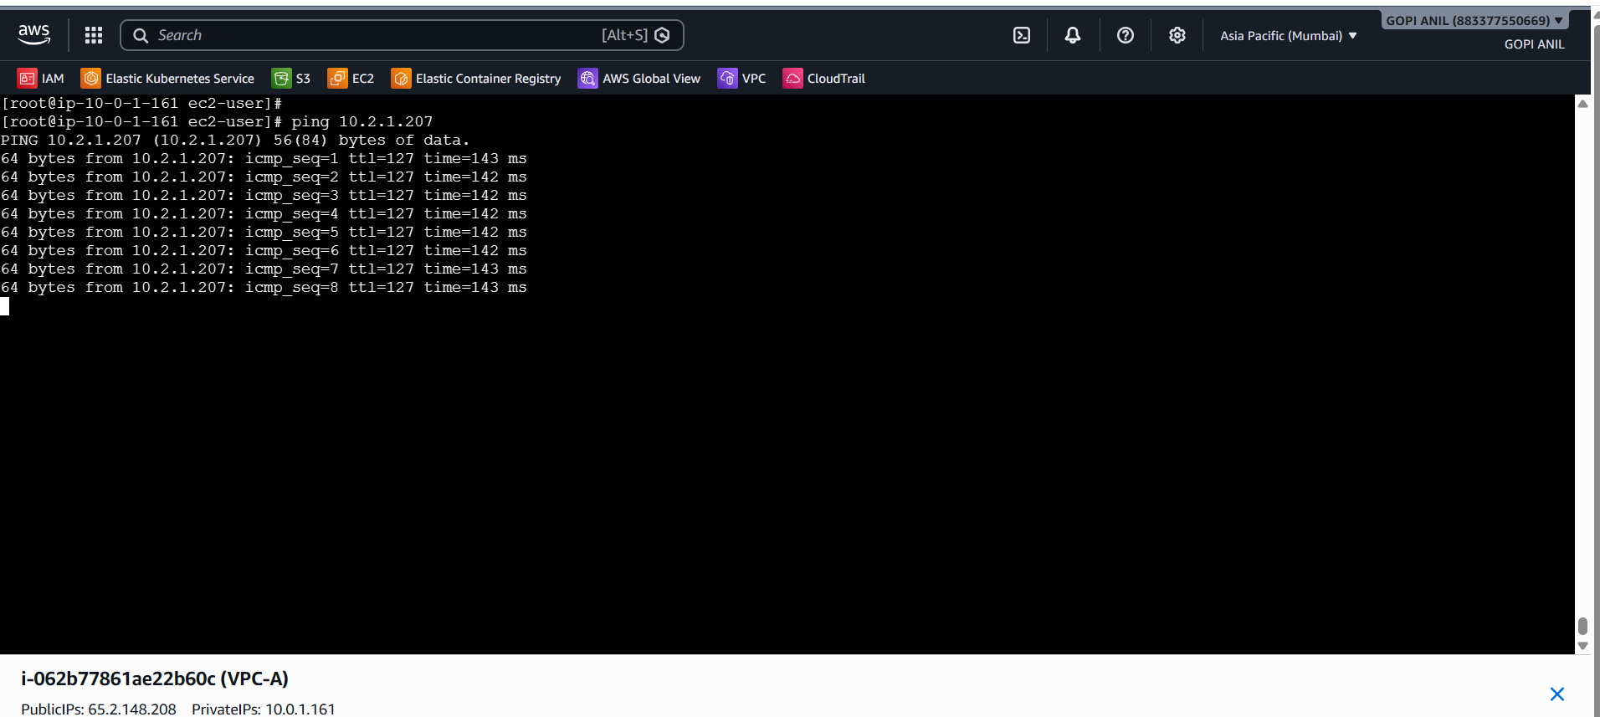
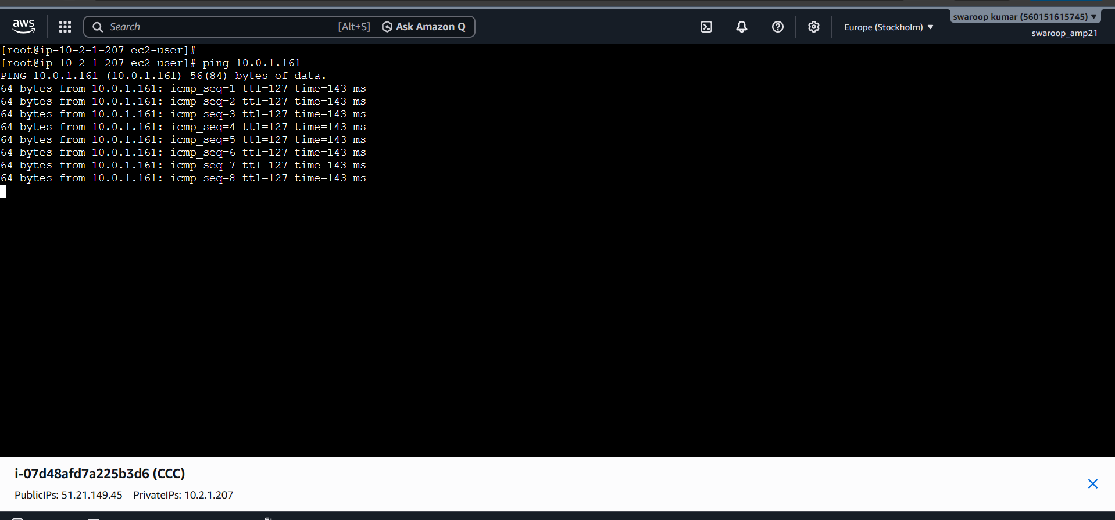

✅ Task 3 Complete: Cross-account peering established between your Lab-VPC-A and your friend's Lab-VPC-C.

TASK 4: Set Up a VPC Transit Gateway
Goal: Use a Transit Gateway (TGW) to connect multiple VPCs centrally (more scalable than mesh peering). This attaches VPC-A and a new VPC-D (10.3.0.0/16) via TGW.

Step 4.1 — Create the Additional VPC (if not already present)
1. Region: ap-south-1 → Create VPC → Name: VPC-D, CIDR: 10.3.0.0/16.
2. Create a subnet: 10.3.1.0/24 in ap-south-1a, name VPC-D-Subnet.
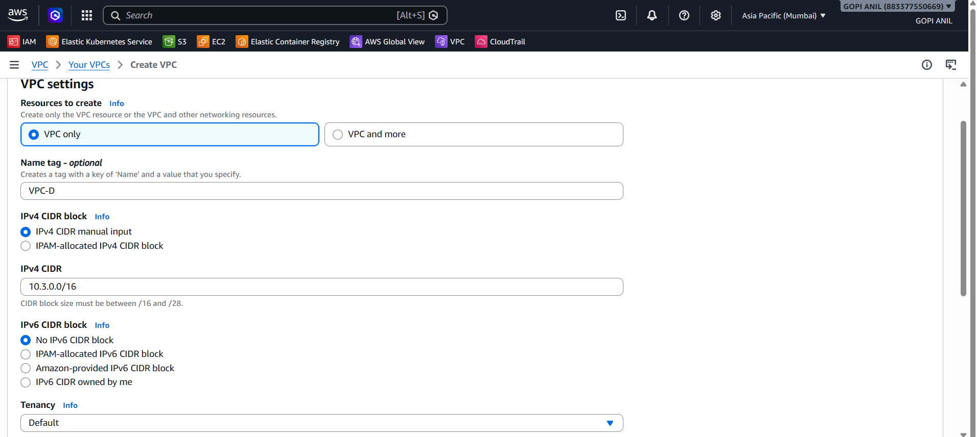
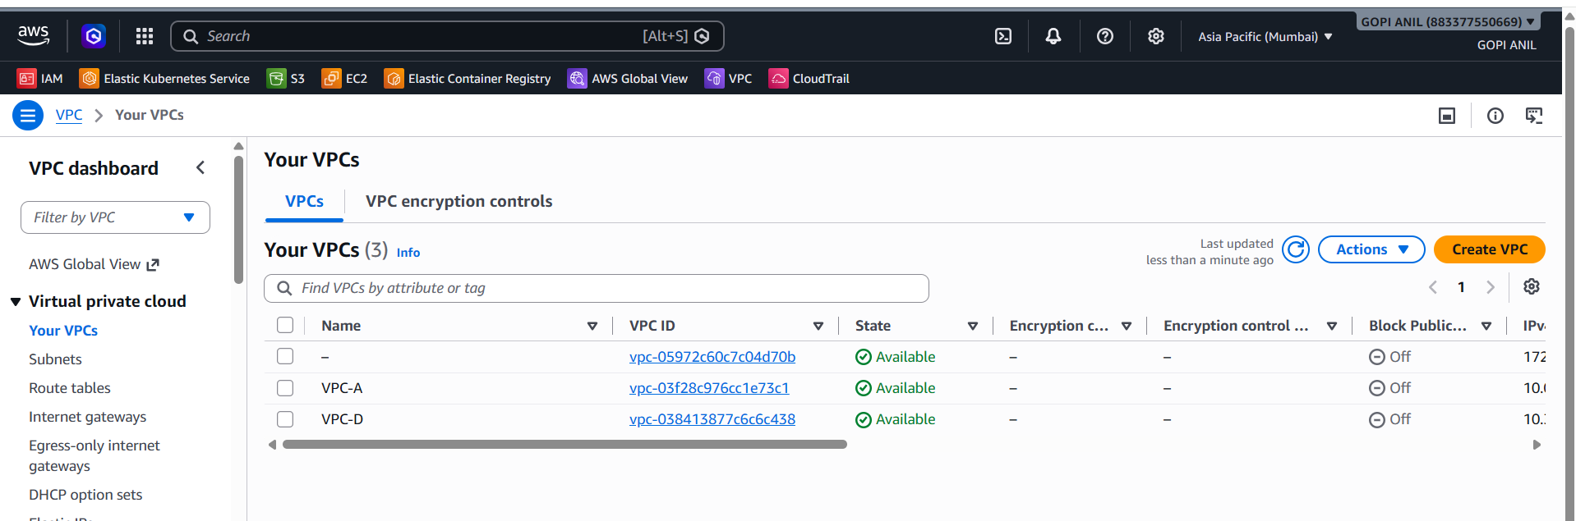
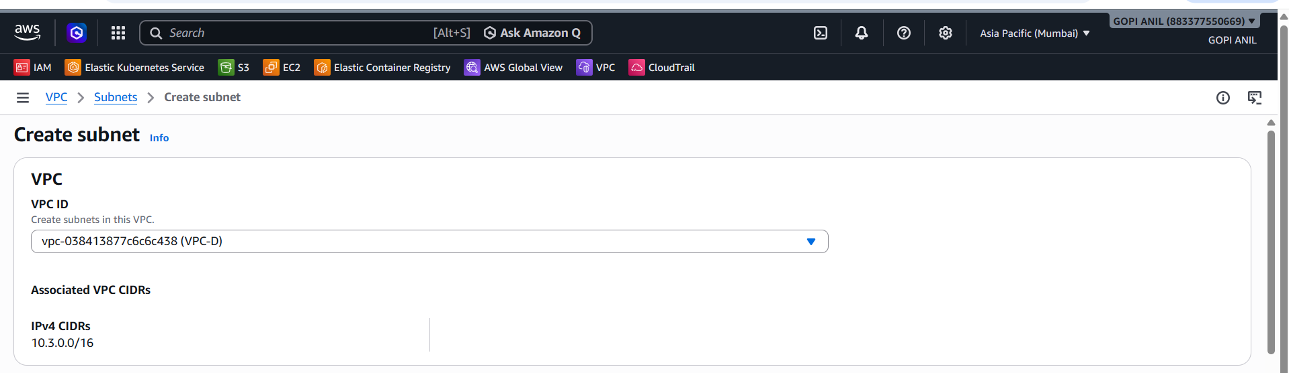
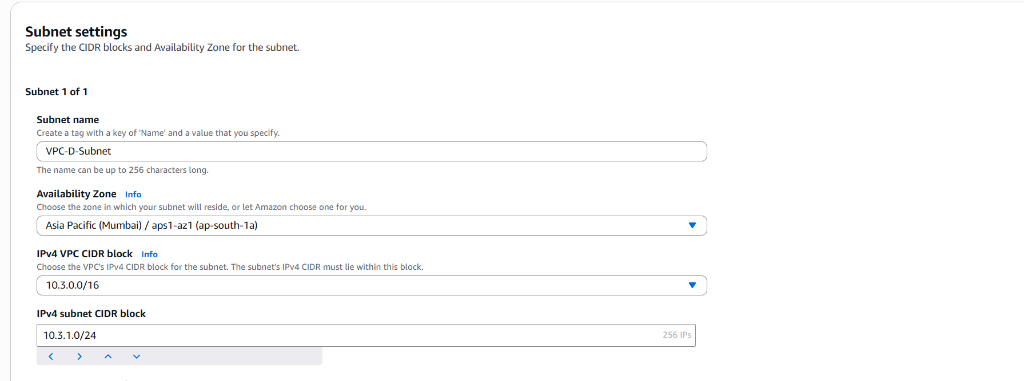

Step 4.2 — Create the Transit Gateway
1. VPC Console → left pane → Transit Gateways → Create Transit Gateway.
2. Name tag: TGW. Description: Central TGW for VPCs.
3. Amazon side ASN: leave default (64512).
4. DNS support: Enable. VPN ECMP support: Enable (default).
5. Default route table association: Enable. Default route table propagation: Enable.
6. Auto accept shared attachments: Disable (default; keep for security).
7. Click Create Transit Gateway. Wait until state = Available (a few minutes).
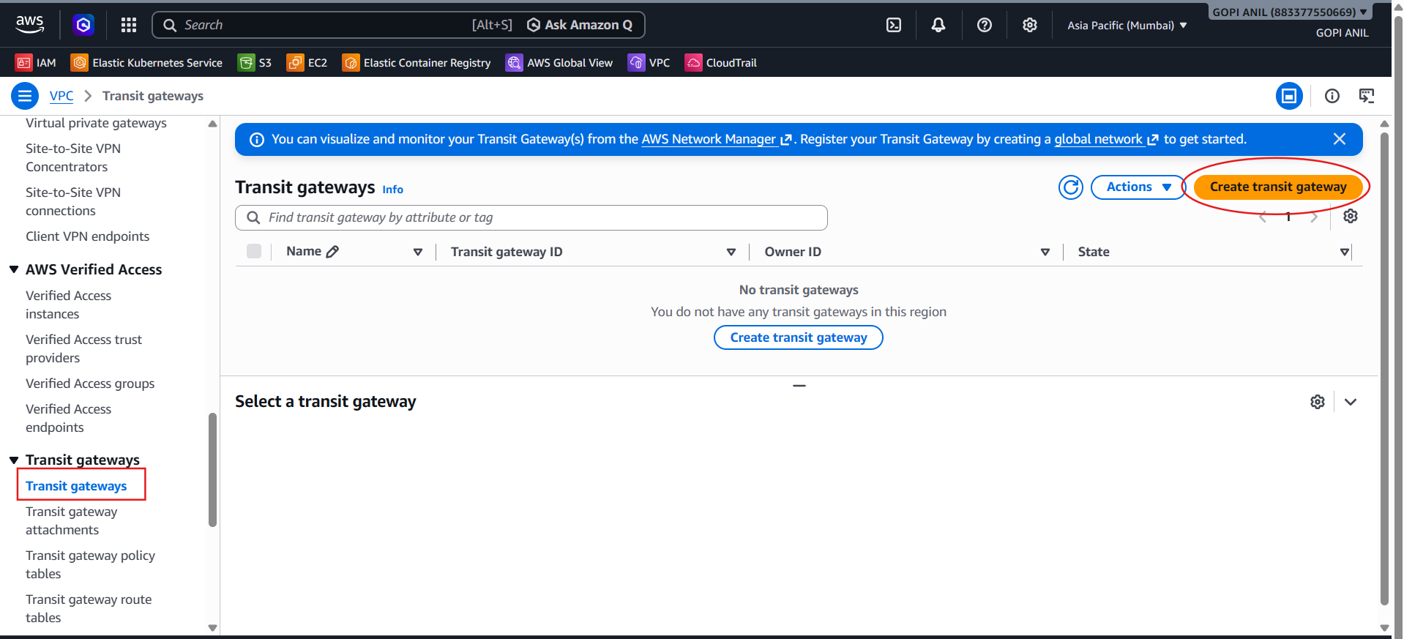
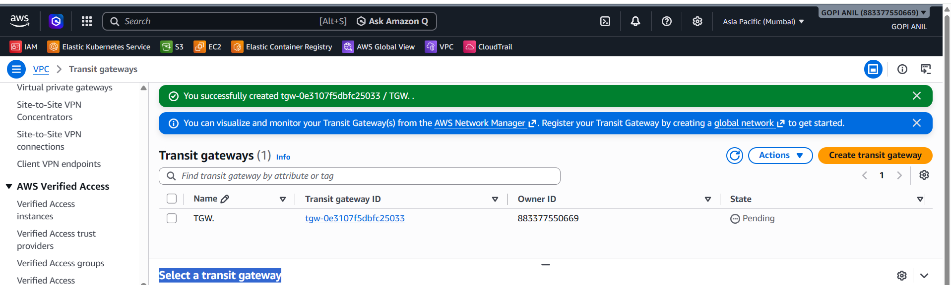

Step 4.3 — Create a Transit Gateway Attachment for VPC-A
1. Left pane → Transit Gateway Attachments → Create Transit Gateway Attachment.
2. Transit Gateway ID: TGW. Attachment type: VPC.
3. Attachment name tag: TGW-Attach-VPC-A. VPC ID: VPC-A.
4. Subnet IDs: select Lab-Private-Subnet (best practice: attach via a dedicated subnet in each AZ that needs TGW reachability).
5. Click Create Transit Gateway Attachment. Wait for state = Available.
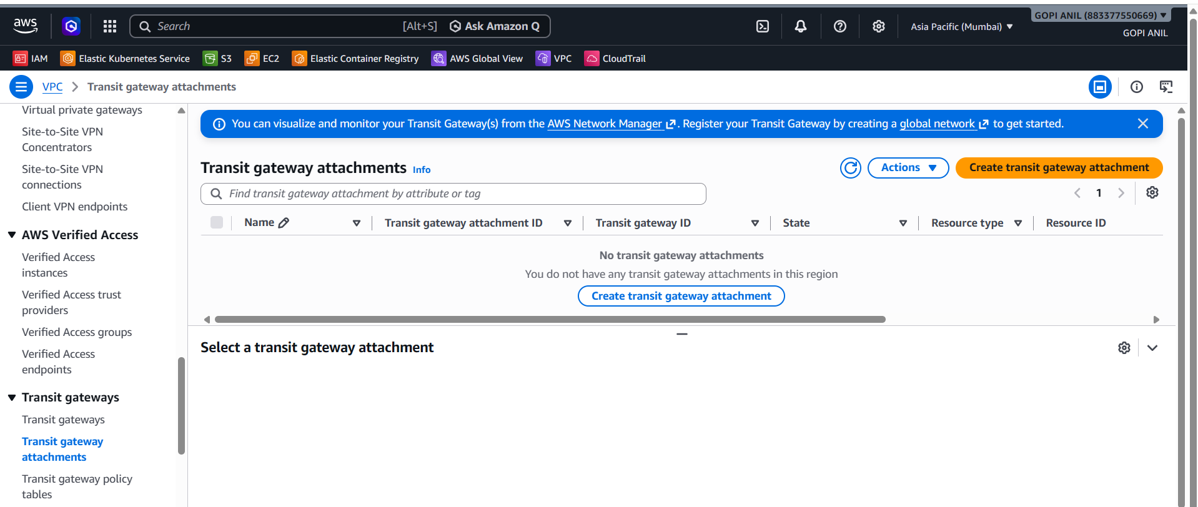
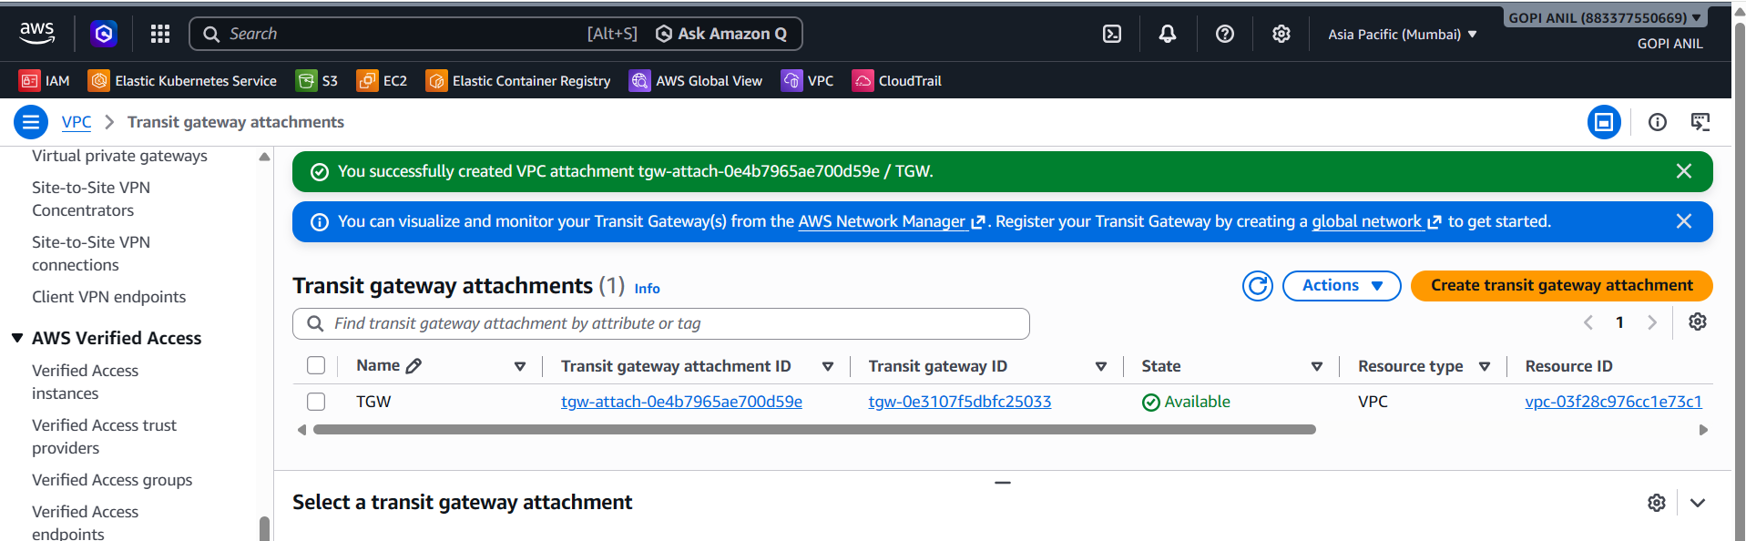

Step 4.4 — Create a Transit Gateway Attachment for VPC-D
1. Repeat Step 4.3 with: Attachment name tag = TGW-Attach-VPC-D; VPC ID = Lab-VPC-D; Subnet IDs = Lab-VPC-D-Subnet.
2. Create Transit Gateway Attachment → wait for Available.
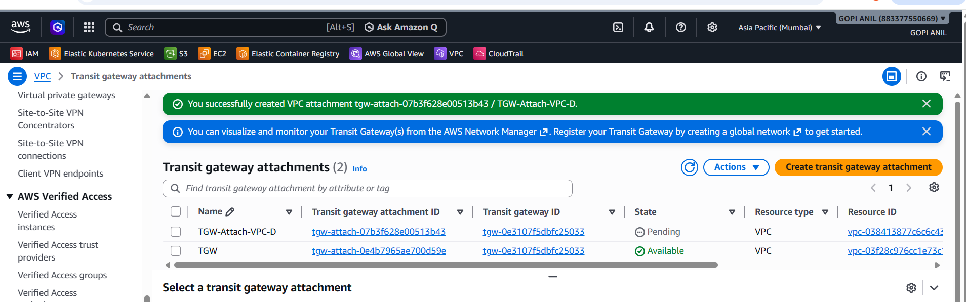

Step 4.5 — Verify/Configure the Transit Gateway Route Table
1. Left pane → Transit Gateway Route Tables → select the default route table associated with Lab-TGW.
2. Associations tab → confirm both TGW-Attach-VPC-A and TGW-Attach-VPC-D are associated.
3. Propagations tab → confirm both attachments propagate routes. If not, click Create propagation and add each attachment.
4. Routes tab → confirm routes exist for 10.0.0.0/16 (via VPC-A attachment) and 10.3.0.0/16 (via VPC-D attachment).
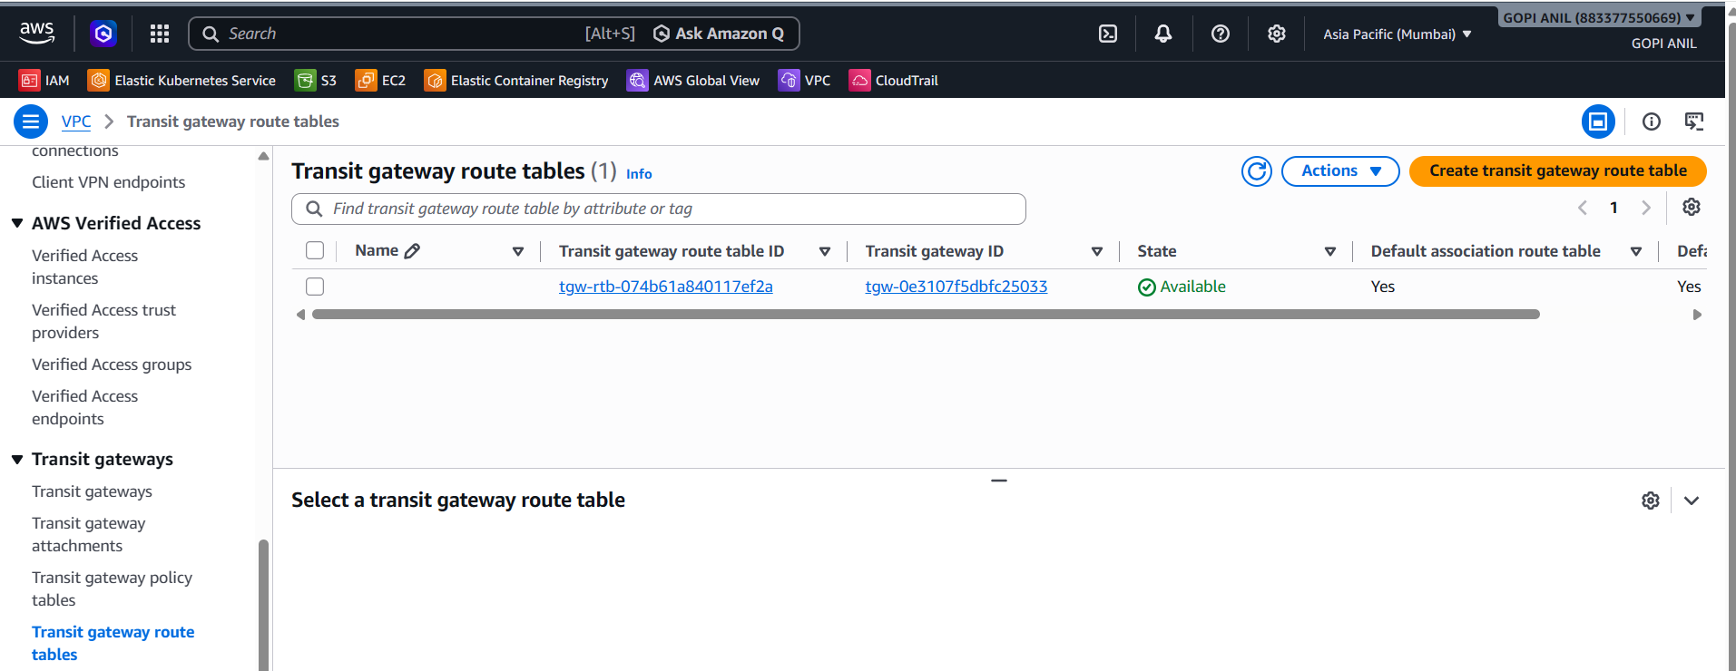

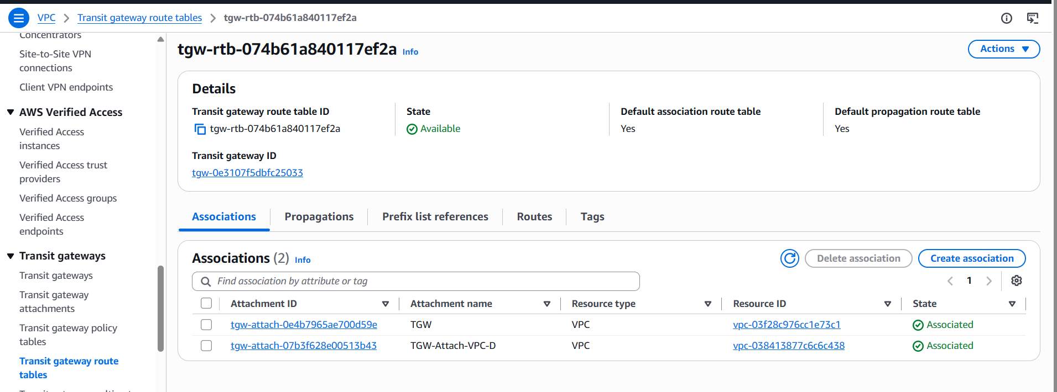
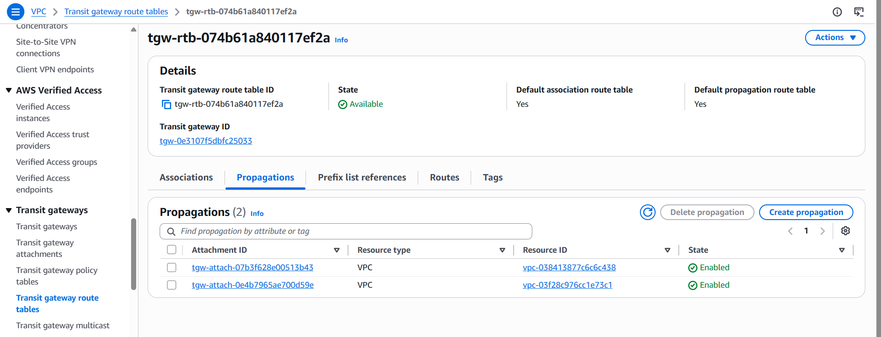
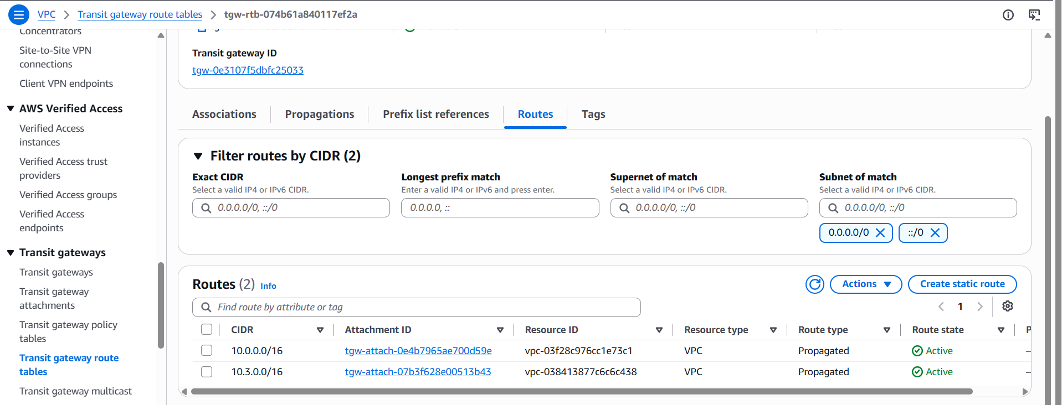

Step 4.6 — Update VPC Route Tables to Point to the TGW
In VPC-A:
1. VPC Console → Route Tables → select Private-RT → Edit routes → Add route: Destination = 10.3.0.0/16; Target = Transit Gateway → select Lab-TGW.
2. Save changes.
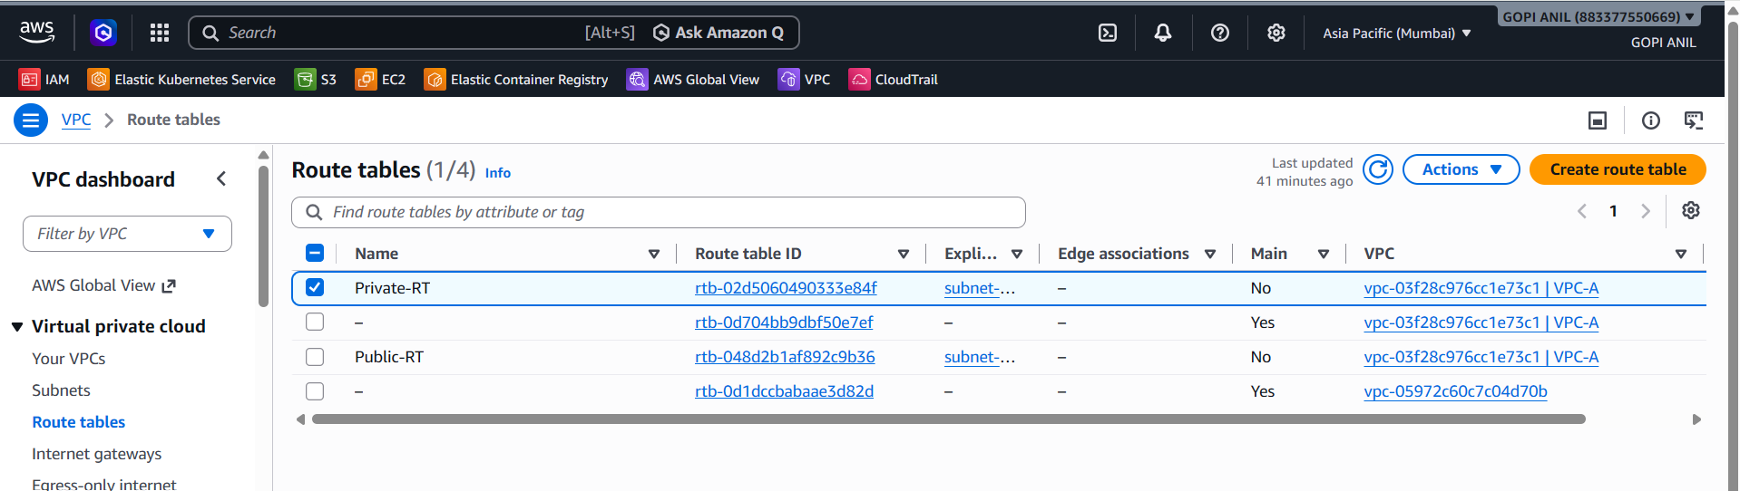
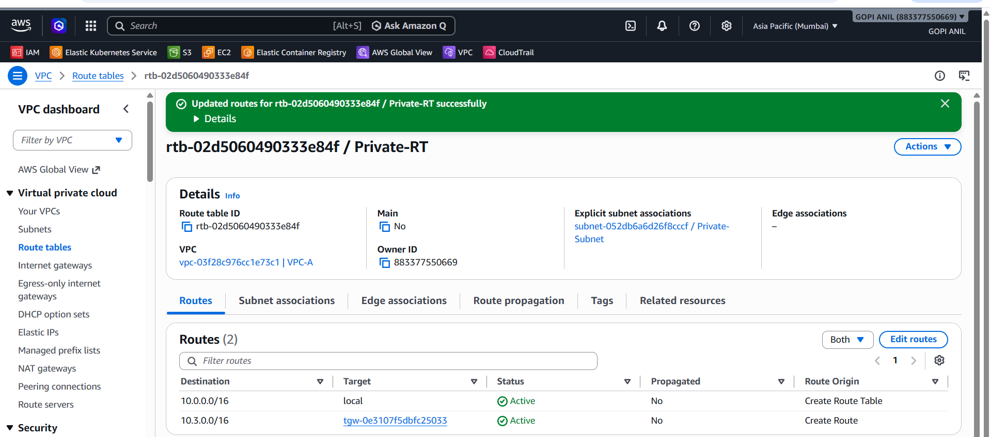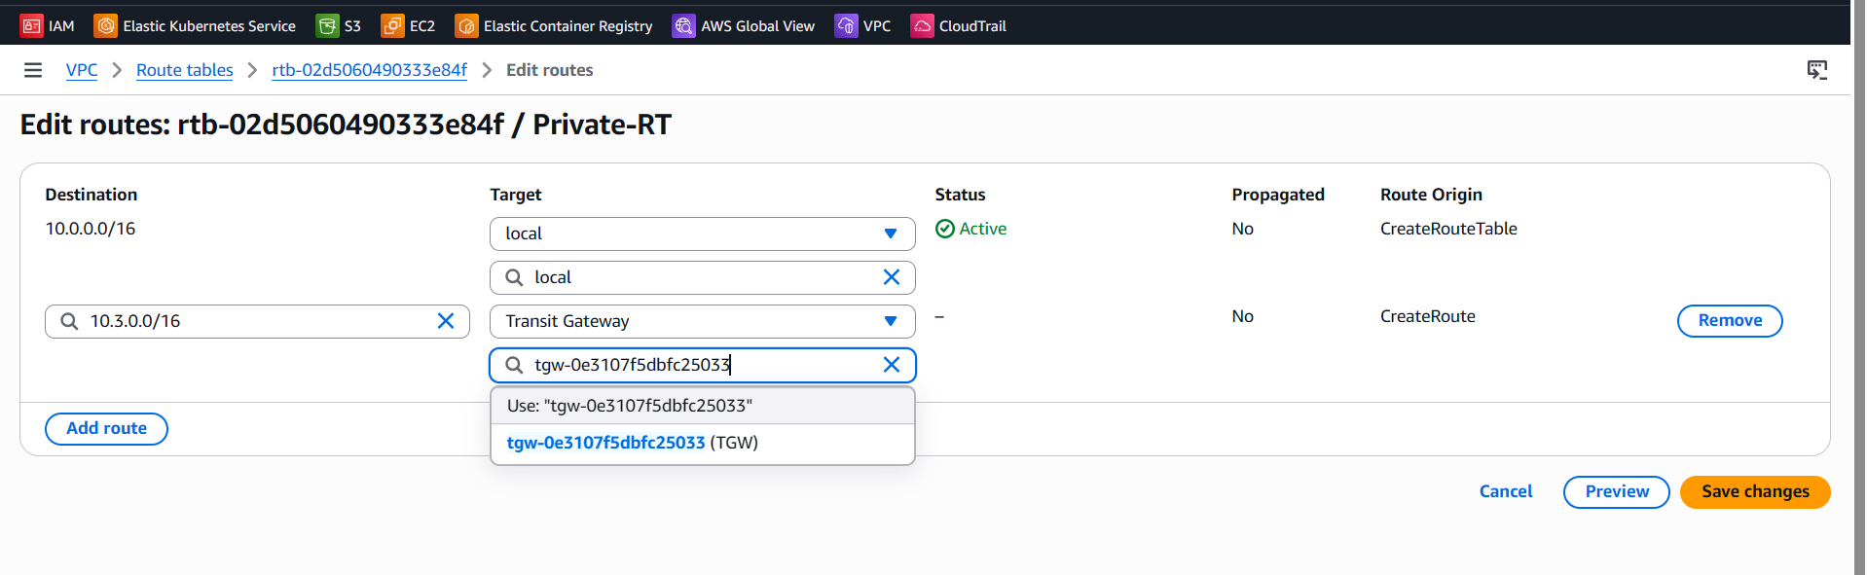

In VPC-D:
3. Select the route table associated with VPC-D-Subnet → Edit routes → Add route: Destination = 10.0.0.0/16; Target = Transit Gateway → select Lab-TGW.
4. Save changes.
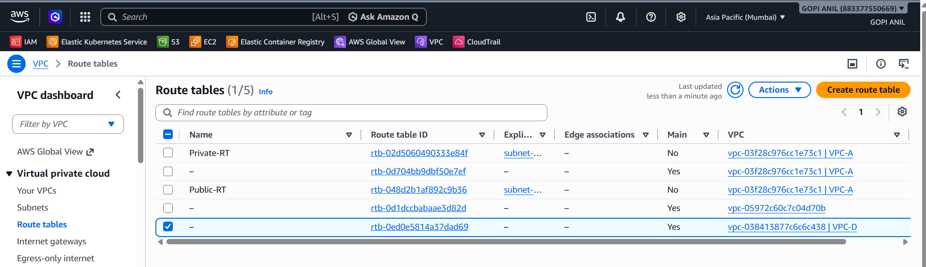

Step 4.7 — Update Security Groups
- Instances in VPC-A: allow inbound from 10.3.0.0/16.
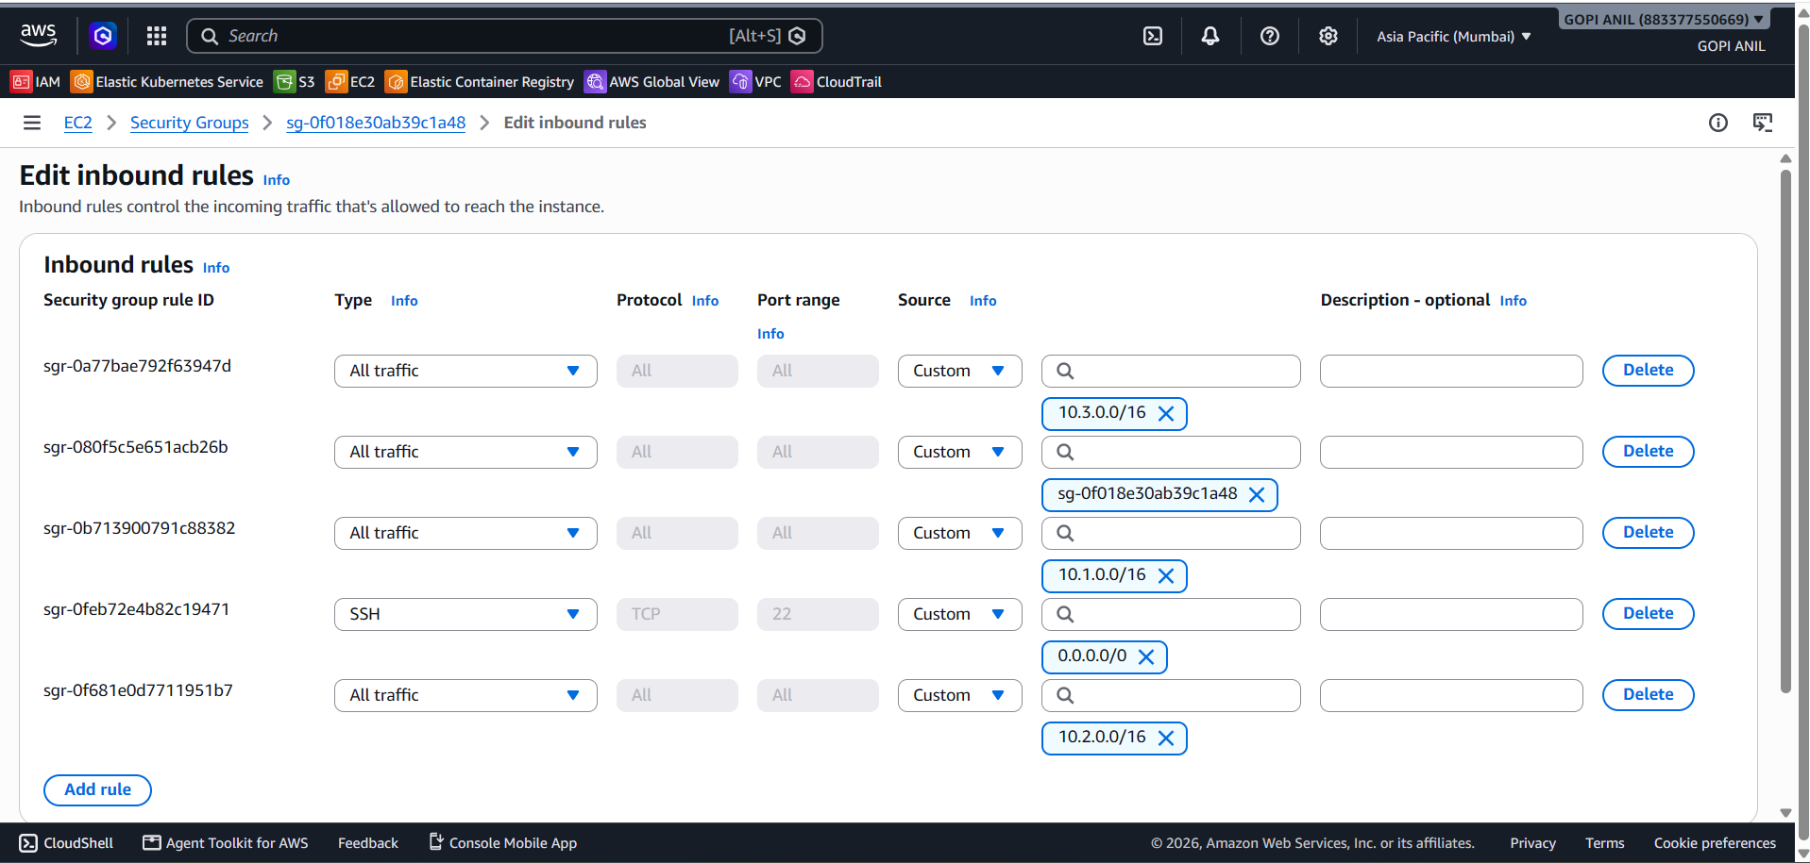
- Instances in VPC-D: allow inbound from 10.0.0.0/16.
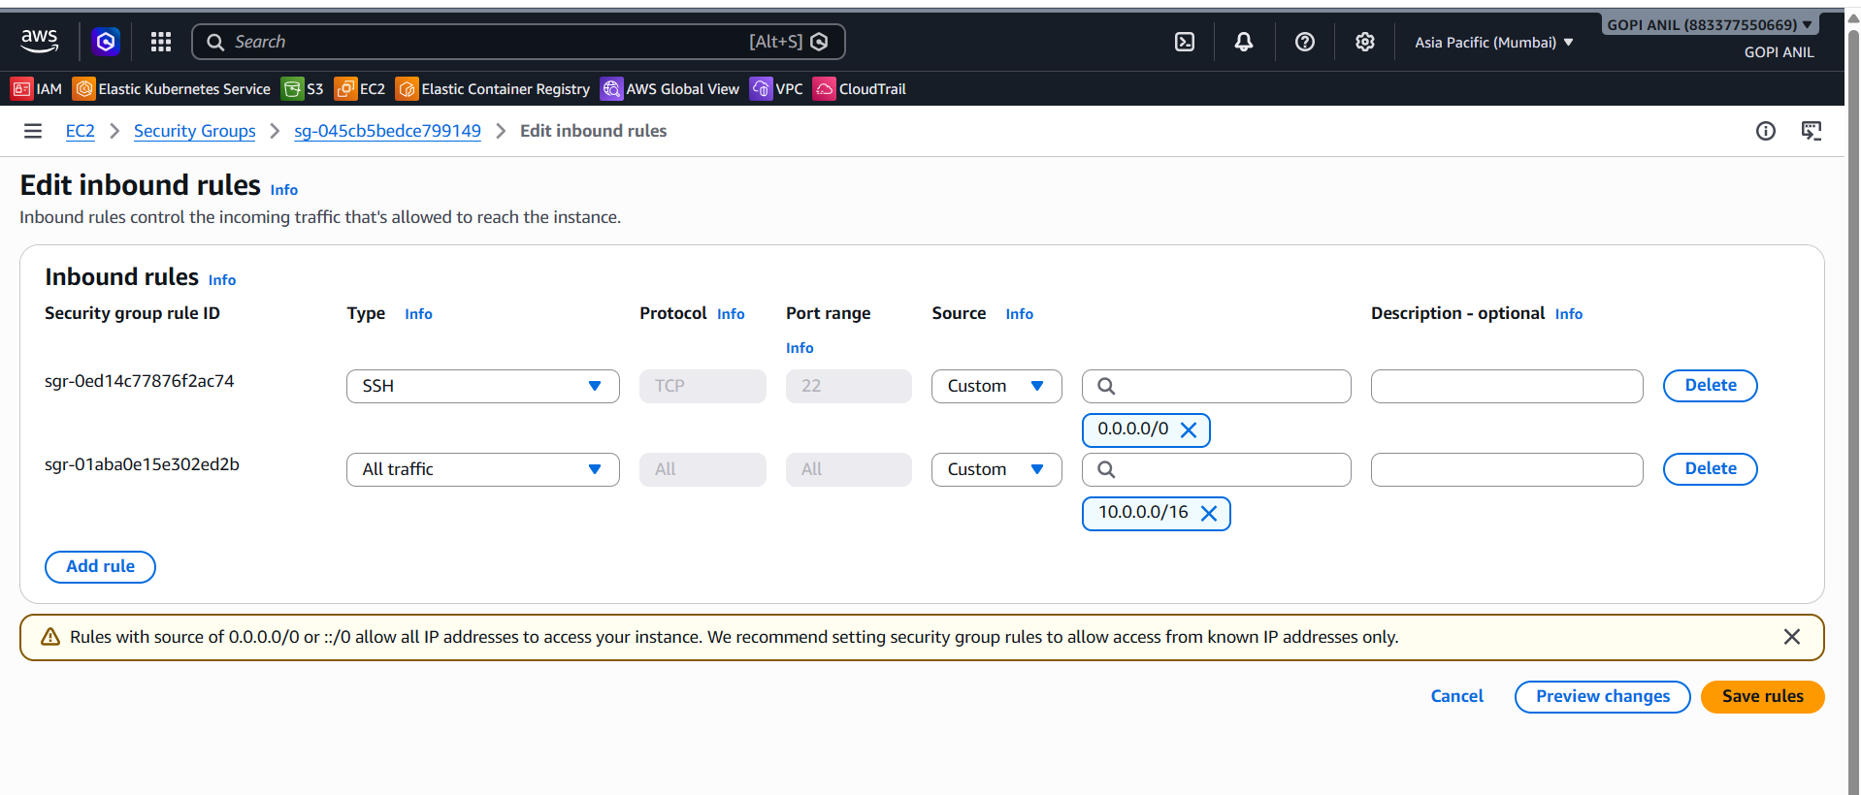

Step 4.8 — Test Connectivity
1. Launch a test EC2 instance in Lab-VPC-D-Subnet.
2. From an instance in Lab-VPC-A, ping/curl the private IP of the instance in VPC-D.
3. A successful reply confirms the Transit Gateway is routing traffic correctly between the two VPCs.
✅ Task 4 Complete: Lab-TGW connects Lab-VPC-A and Lab-VPC-D through a hub-and-spoke model. Additional VPCs, VPNs, or Direct Connect gateways can be attached the same way — this scales far better than full-mesh peering.

TASK 5: Set Up a VPC Endpoint
VPC Endpoints let resources in a VPC reach AWS services privately, without traversing the public internet or a NAT Gateway. There are two types: Gateway Endpoints (S3, DynamoDB only) and Interface Endpoints (powered by AWS PrivateLink, for most other services). This version builds Lab-VPC-A and its test EC2 instance from scratch before configuring either endpoint type.

Step 5.1 — Create VPC-A
1. Region: ap-south-1 → VPC Console → Create VPC → Name: VPC-A, CIDR: 10.0.0.0/16.
2. Create a subnet: 10.0.1.0/24 in ap-south-1a, name Private-Subnet.
3. Create a route table named Private-RT and associate it with Lab-Private-Subnet.
4. (Optional) Create a second subnet, e.g., 10.0.2.0/24 in ap-south-1a, name Lab-Public-Subnet, with a route table Lab-Public-RT, if you want to compare public vs. private endpoint access.
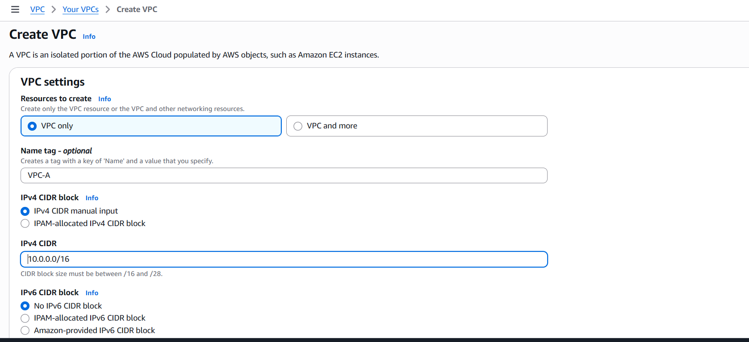
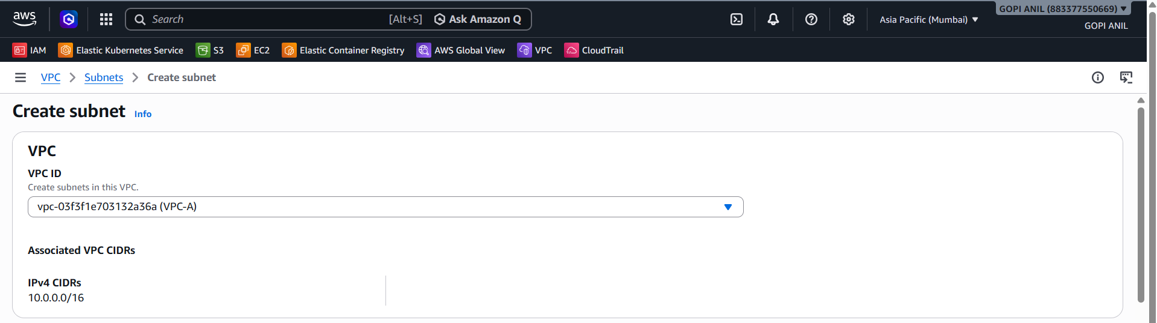
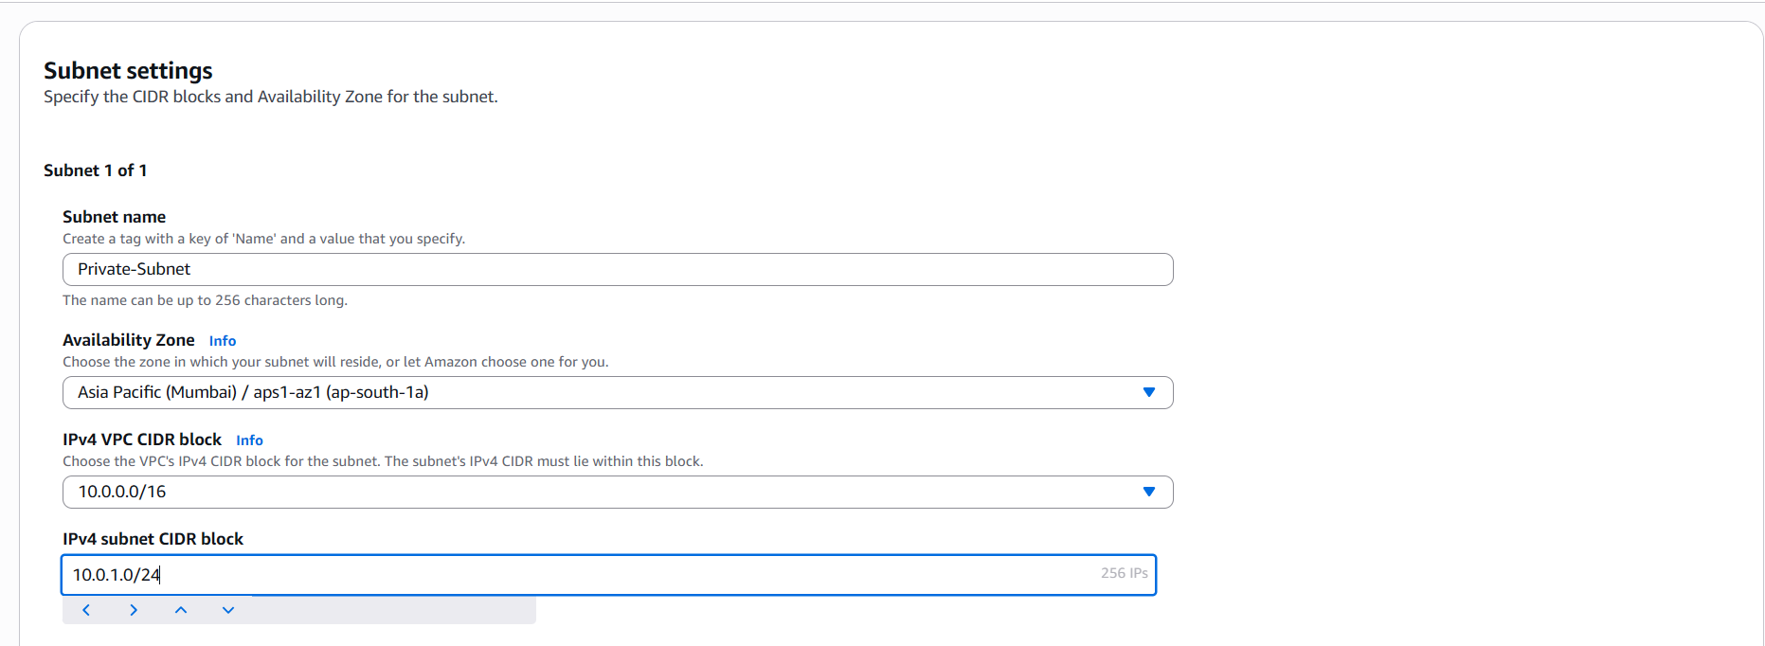
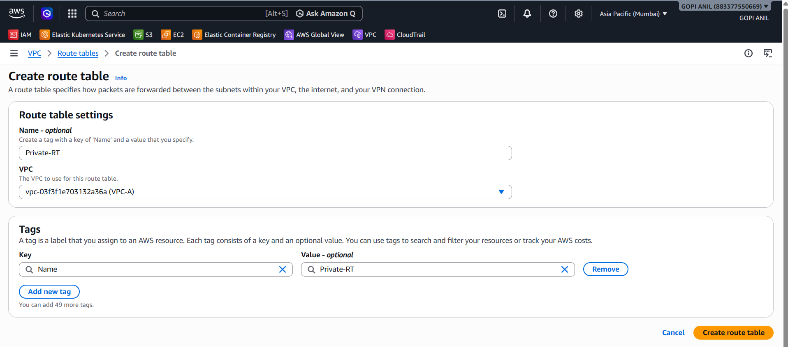

Step 5.2 — Create an IAM Role for the Test Instance
1. IAM Console → Roles → Create role → Trusted entity: AWS service → Use case: EC2.
2. Attach policies: AmazonS3ReadOnlyAccess and AmazonSSMManagedInstanceCore.
3. Role name: Endpoint-Test-Role → Create role.
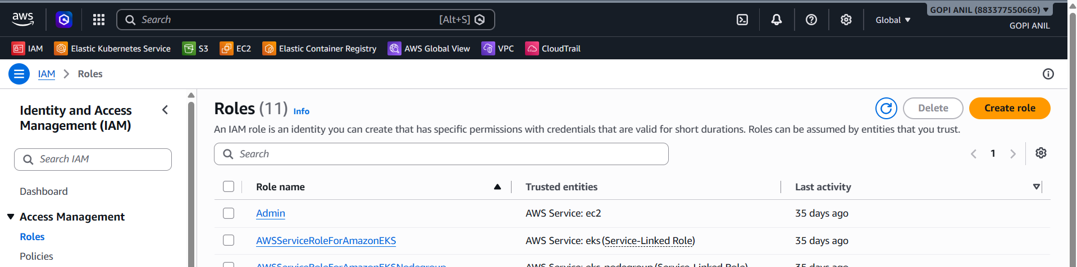
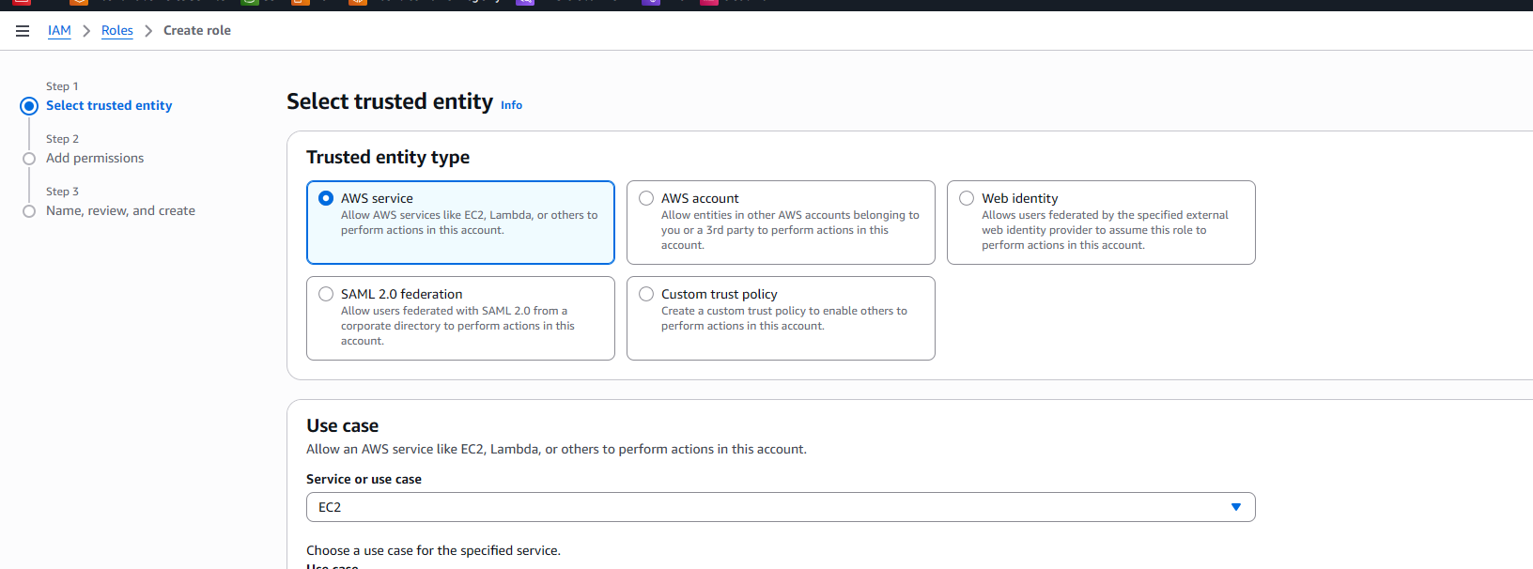
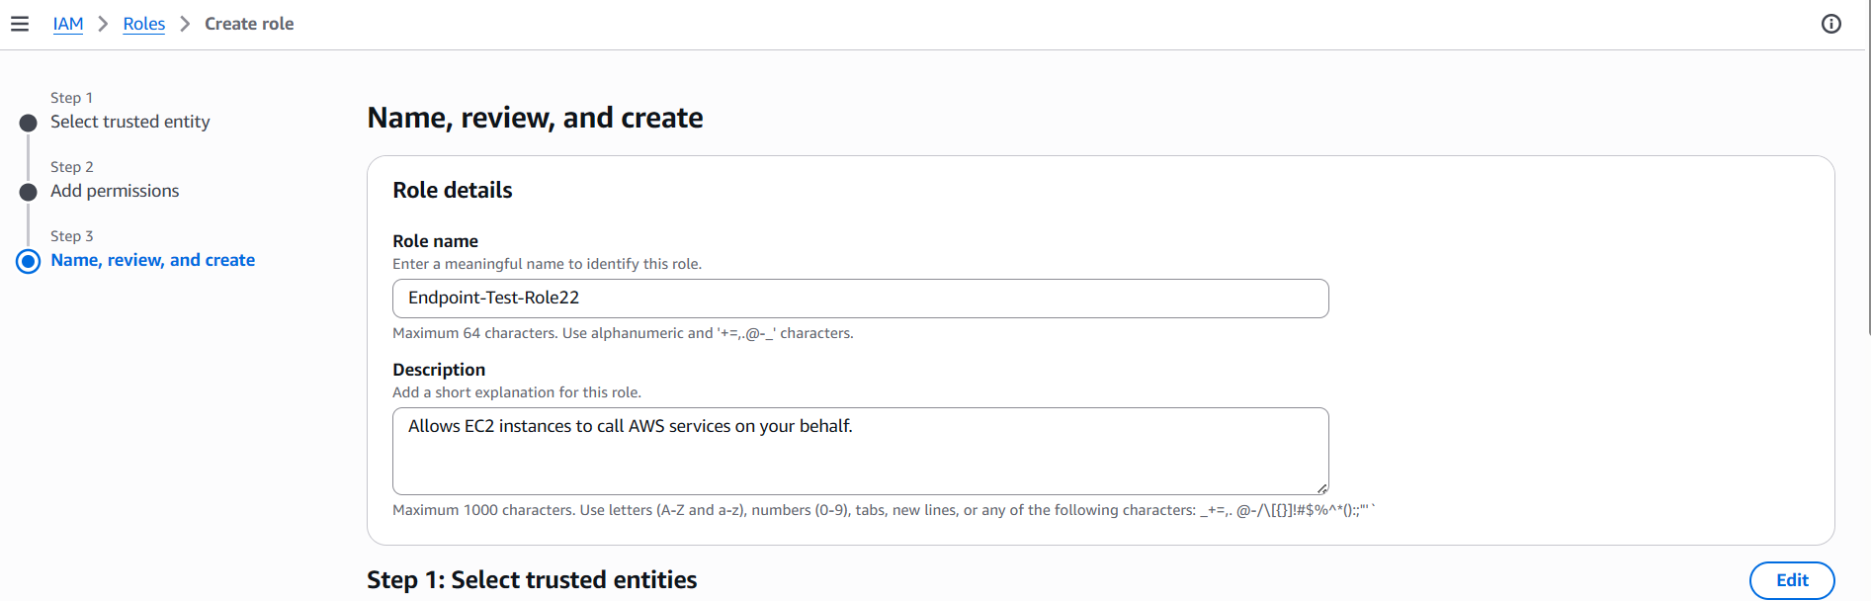
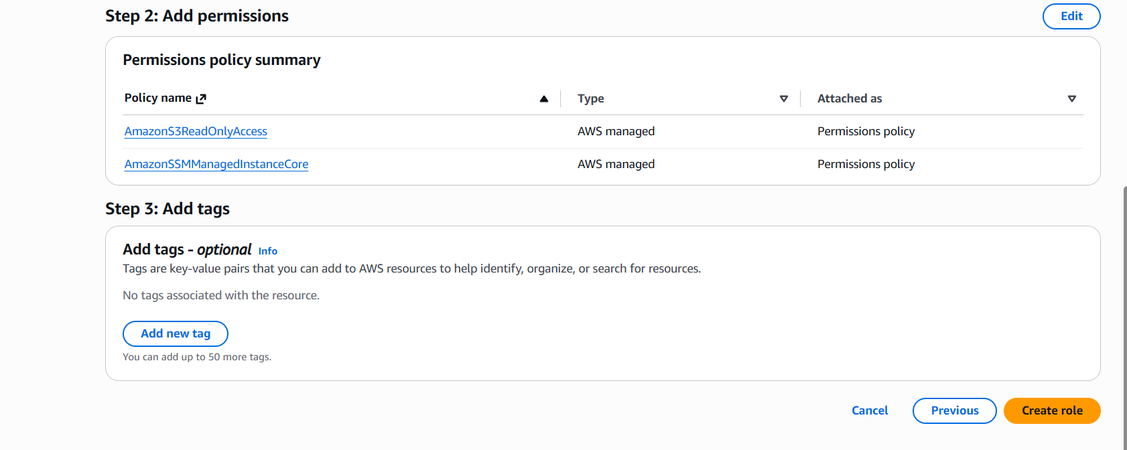

Step 5.3 — Launch a Test EC2 Instance
1. EC2 Console → Launch Instance. Name: Endpoint-Test-Instance.
2. AMI: Amazon Linux 2023 (free tier eligible). Instance type: t3.micro.
3. Key pair: select an existing key pair or create a new one (e.g., Lab-KeyPair).
4. Network settings → VPC: VPC-A. Subnet: Private-Subnet. Auto-assign public IP: Disable.
5. Firewall (security group): create/select Private-SG allowing outbound HTTPS (443) — needed to reach the endpoints.
6. Advanced details → IAM instance profile: Lab-Endpoint-Test-Role.
7. Click Launch Instance. Wait until Instance State = Running and Status Checks = 2/2 passed.
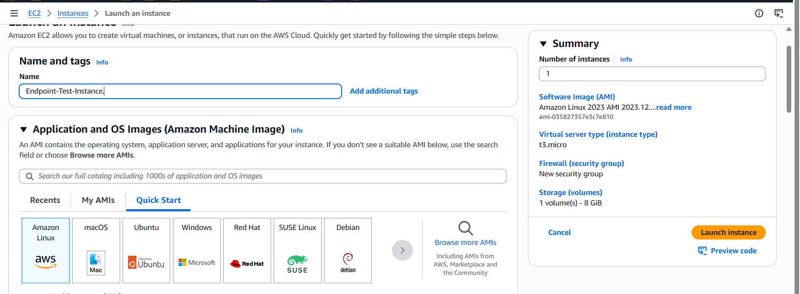
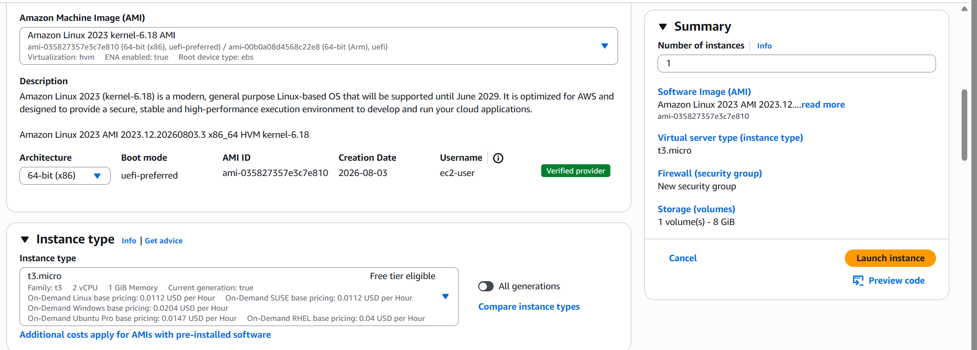
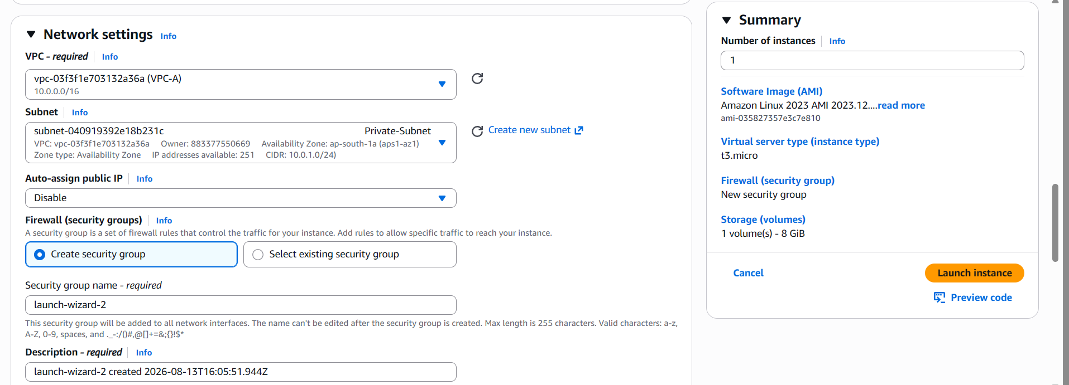
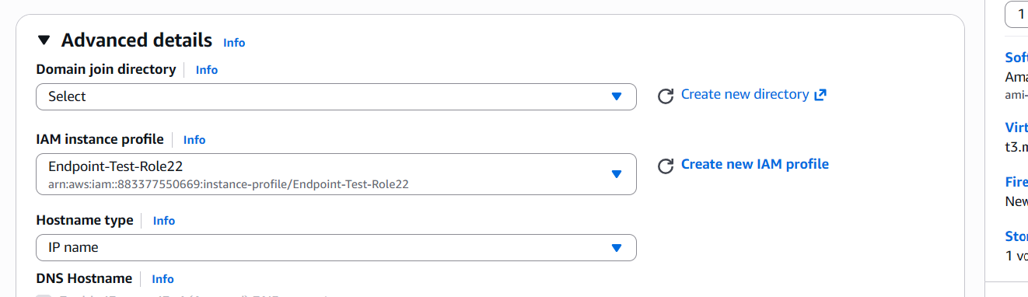

PART A — Gateway Endpoint (Amazon S3 example)

Step 5A.1 — Open Endpoints Console
- VPC Console → left pane → Endpoints → Create endpoint.
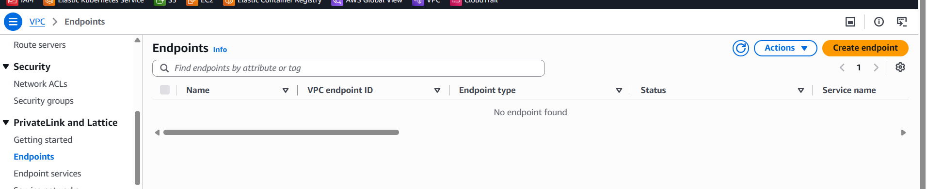

Step 5A.2 — Configure the Gateway Endpoint
1. Name tag: Gateway-Endpoint.
2. Service category: AWS services.
3. Services: search s3 → select the entry with Type = Gateway, e.g., com.amazonaws.ap-south-1.s3.
4. VPC: VPC-A.
5. Route tables: check Private-RT (and Public-RT if created) — AWS auto-inserts a route for the S3 prefix list in these tables.
6. Policy: Full access (default), or a custom policy to restrict to specific buckets.
7. Click Create endpoint.
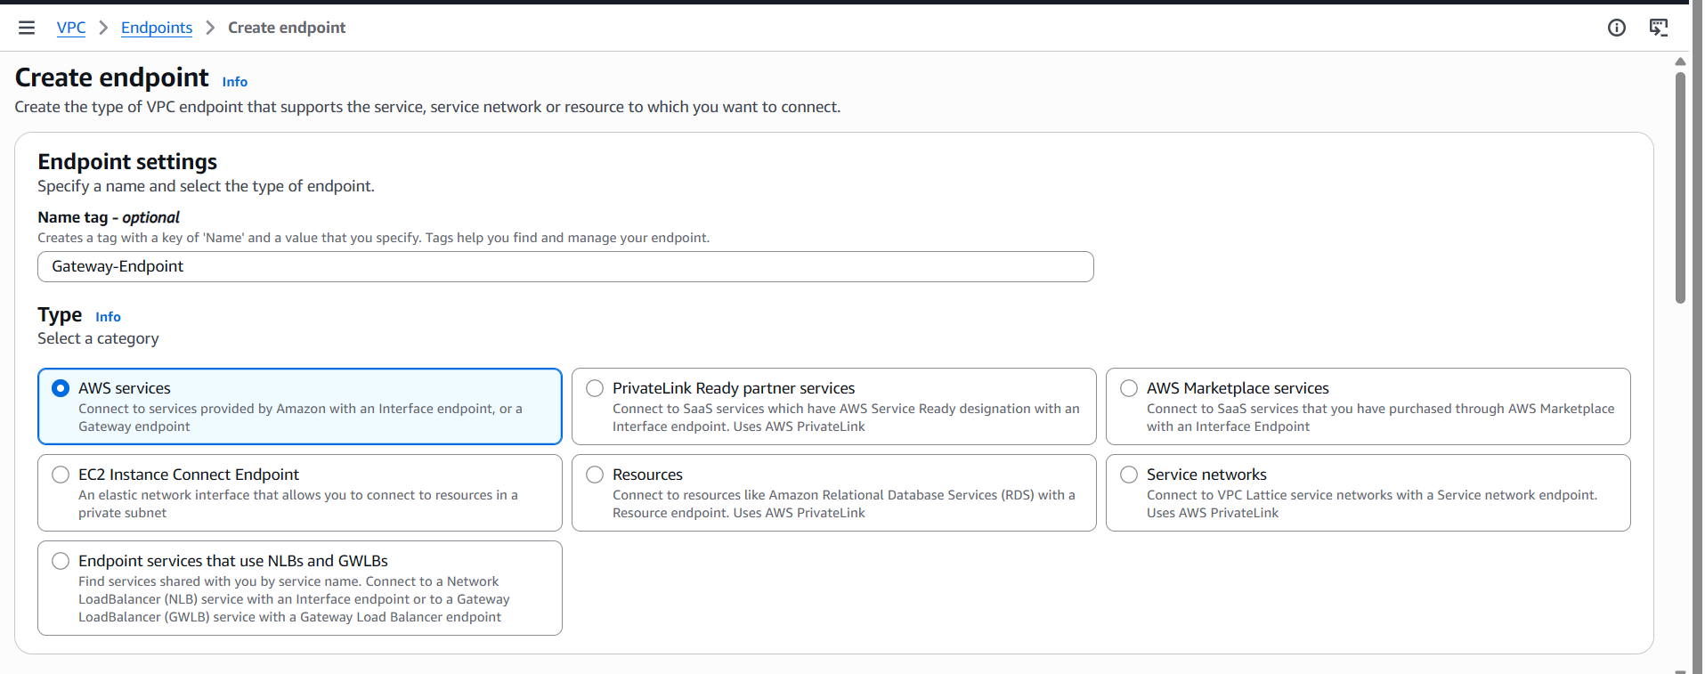
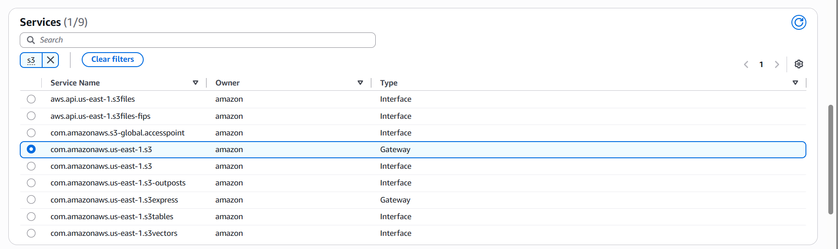
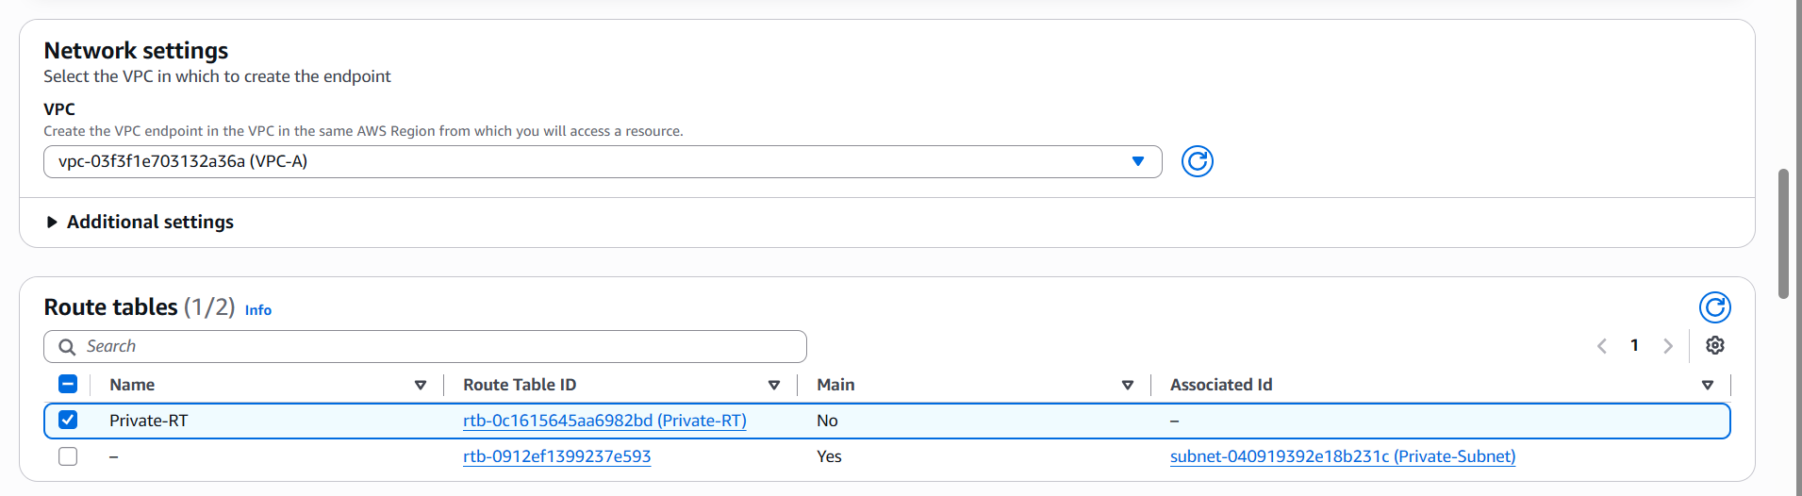
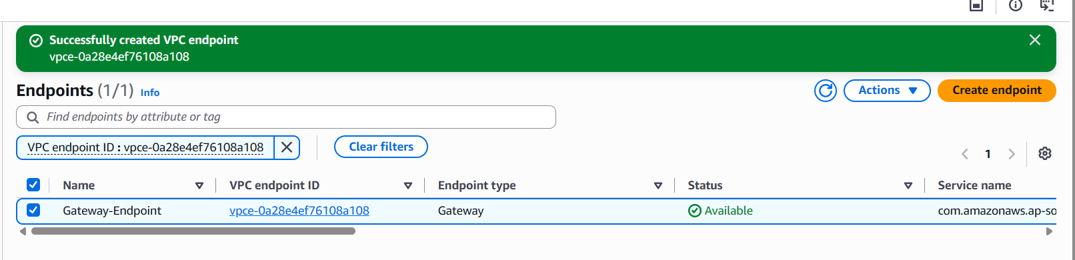

Step 5A.3 — Verify
1. Go to Route Tables → Private-RT → Routes tab.
2. Confirm a new route exists: Destination = pl-xxxxxxxx (com.amazonaws.ap-south-1.s3); Target = vpce-xxxxxxxx.
3. Connect to Lab-Endpoint-Test-Instance (via Session Manager once Part B is complete, or via a bastion) and run the command below — it succeeds privately through the endpoint using the instance's IAM role:
aws s3 ls
